Practical File of

**WEB-BASED PROGRAMMING LAB**

**(BCA 172)**

**BACHELOR OF COMPUTER APPLICATIONS**

Academic Session: - 2021-22

Batch: - 2021-24



**Submitted To: Submitted By:**

**MS. AMBOOJ YADAV orav goyal**

**Enrolment No: - 00721302021**

**Programme: - BCA**

**Semester: - 2**

**Shift: - EVENING**

**Division: - A**



**INDEX**

|  |  |  |
| --- | --- | --- |
| **S.NO** | **TOPIC** | **SIGNATURE** |
|  | **Write regular expressions including modifiers, operators, and metacharacters.** |  |
|  | **Write a program to show the usage of the nested if statement.** |  |
|  | **Write a Program in PHP for type Casting of a Variables.** |  |
|  | **Write a program to create a menu-driven program and show the usage of switch-case.** |  |
|  | **Write a program to show the usage of for/while/do-while loop.** |  |
|  | **Write a program to perform all four types of sorting.** |  |
|  | **Write a program to implement Arraypad(),aaray_slice(),array_splice(),list() functions.(use foreach wherever applicable)** |  |
|  | **Write a program to show the application of user-defined functions.** |  |
|  | **Write a program that Passes control to another page (include, require, exit and die functions)** |  |
|  | **Write a program to validate the form data using the Filter var() function.** |  |
|  | **Write a program to show the usage of Cookies.** |  |
|  | **Write a program to show the usage of Session.** |  |
|  | **Write a program to implement the oops concept.** |  |
|  | **Do Form handling In PHP Design a personal Information form, then Submit & Retrieve the Form Data Using $_GET(), $_POST() and $_REQUEST() Variables.** |  |
|  | **Design A Login Form and Validate that Form using PHP Programming.** |  |
|  | **Create Admin Login, Logout form using session variables** |  |

**PROGRAM 1.**

**Write regular expressions including modifiers, operators, and metacharacters.**

**ARITHMETIC OPERATORS:**

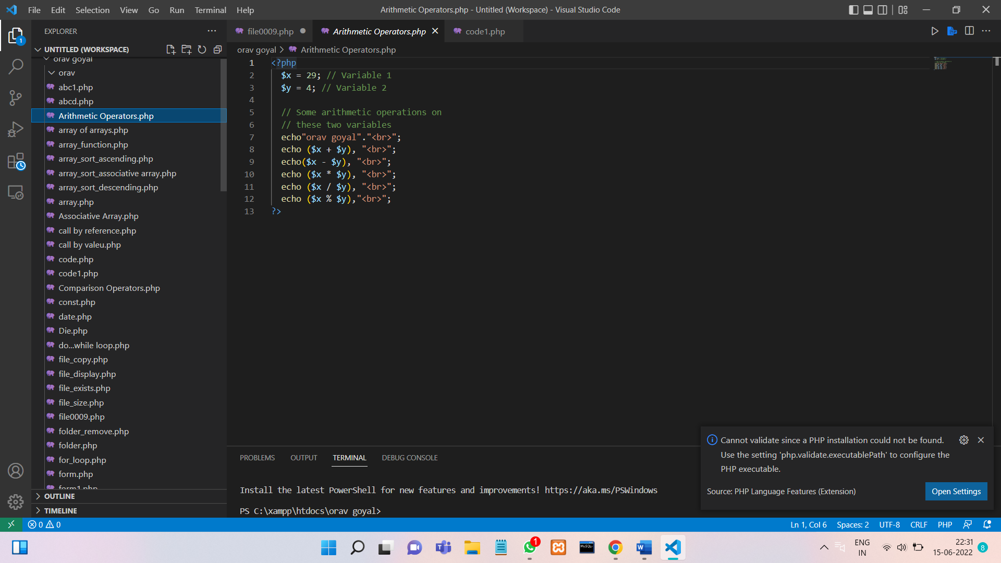

**OUTPUT :**

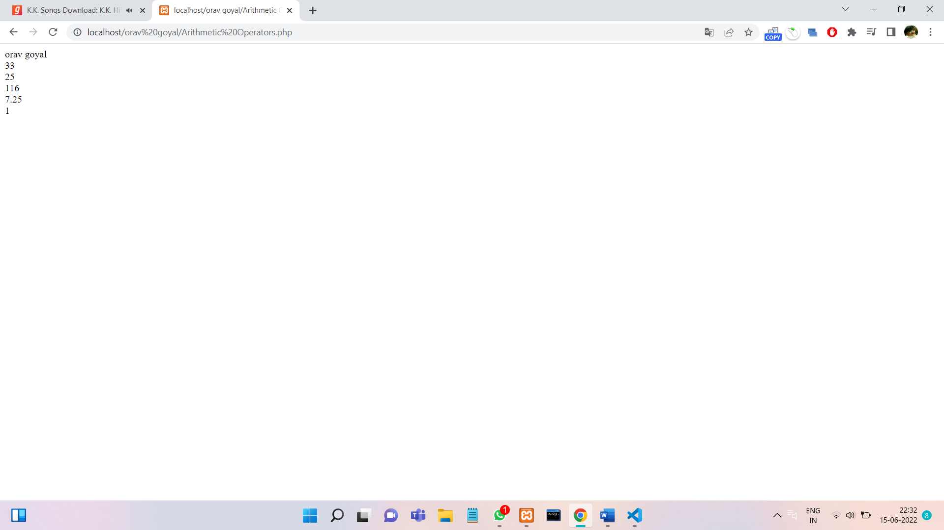

**COMPARISON OPERATORS:**

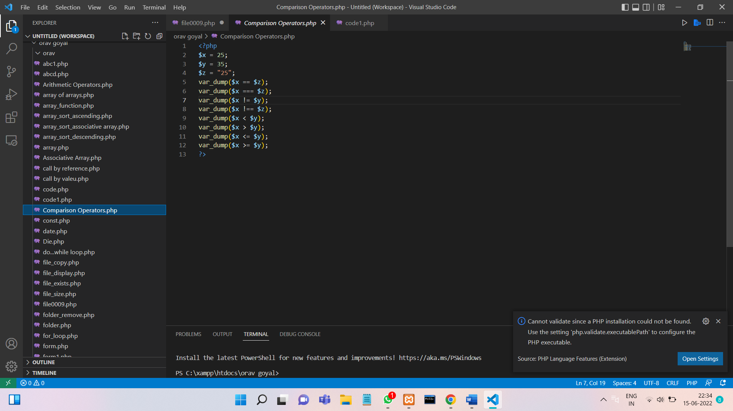

**OUTPUT :**

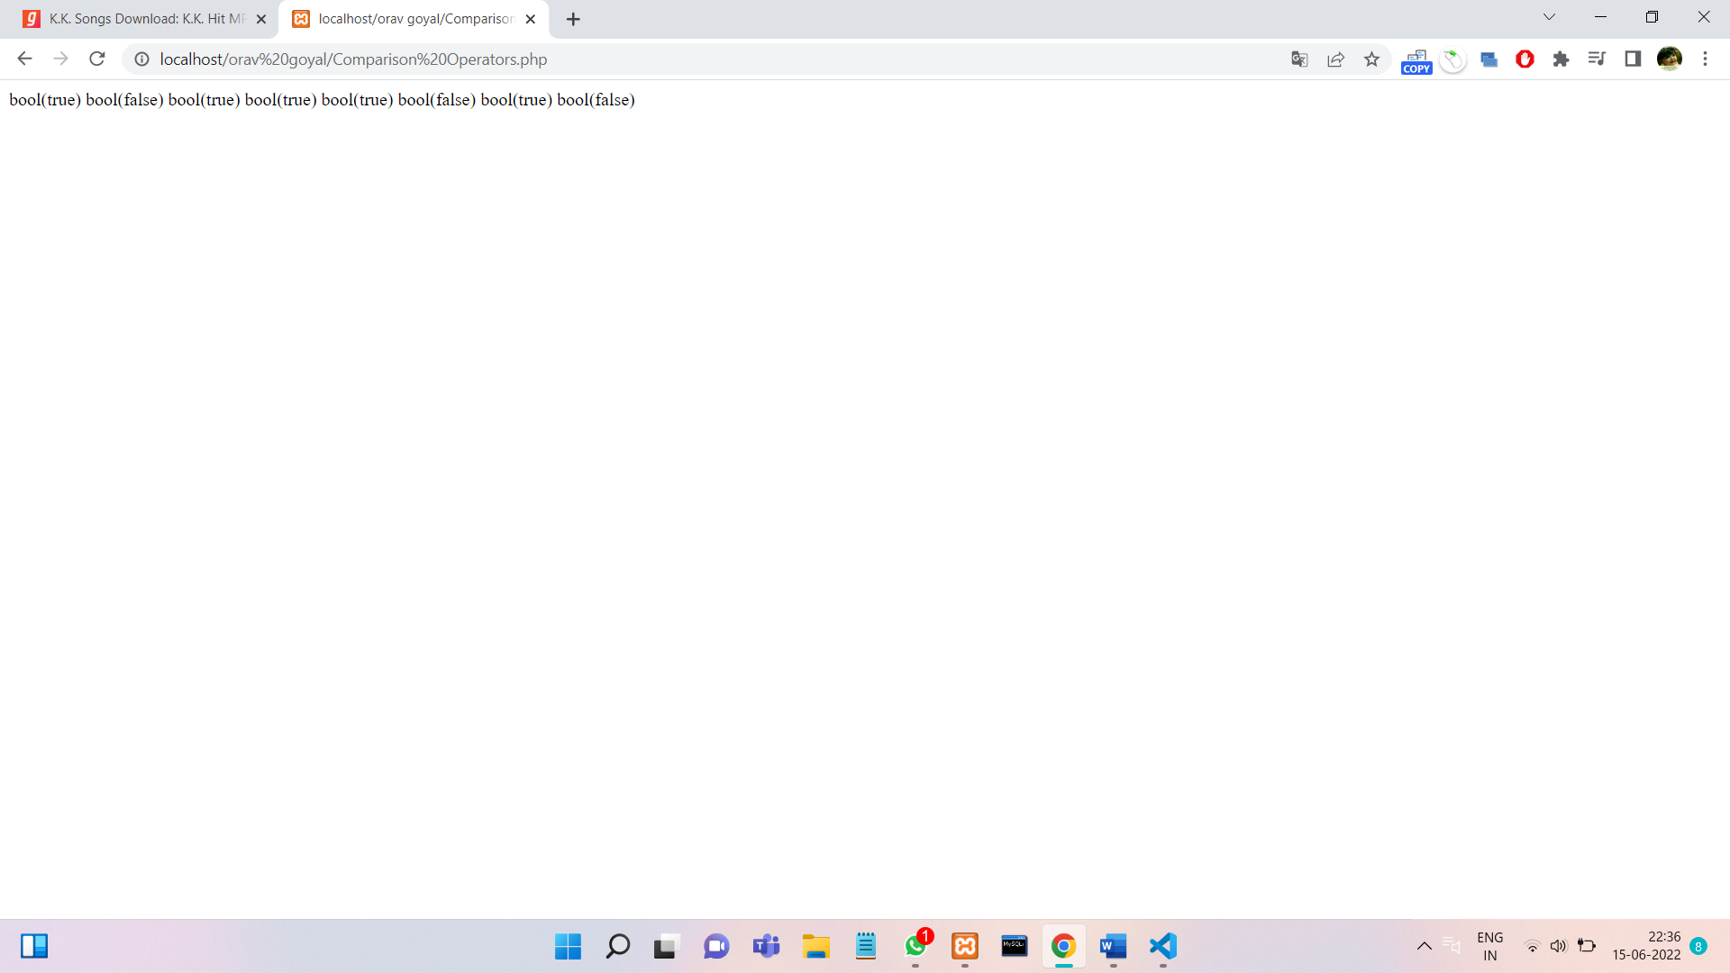

**INCREMENT / DECREMENT OPERATORS:**

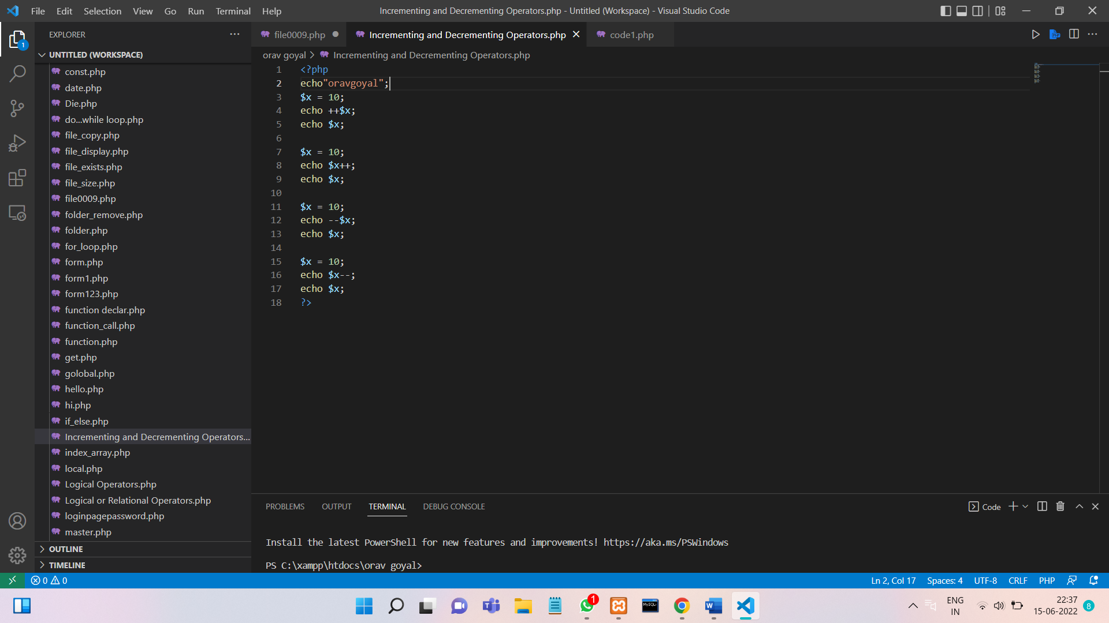

**OUTPUT :**

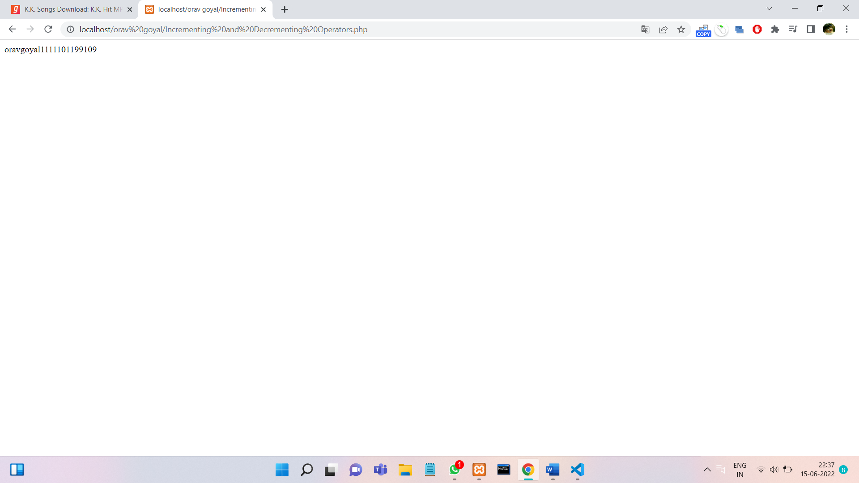

**LOGICAL OPERATORS:**

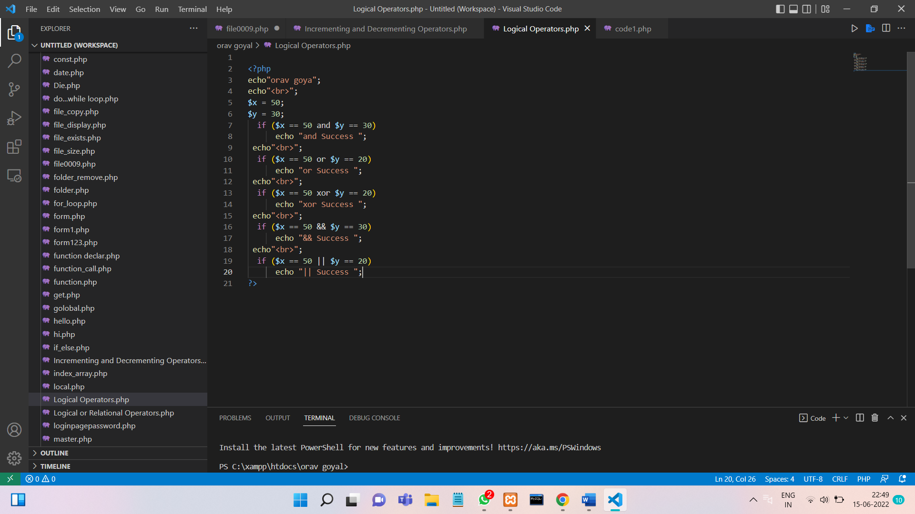

**OUTPUT :**

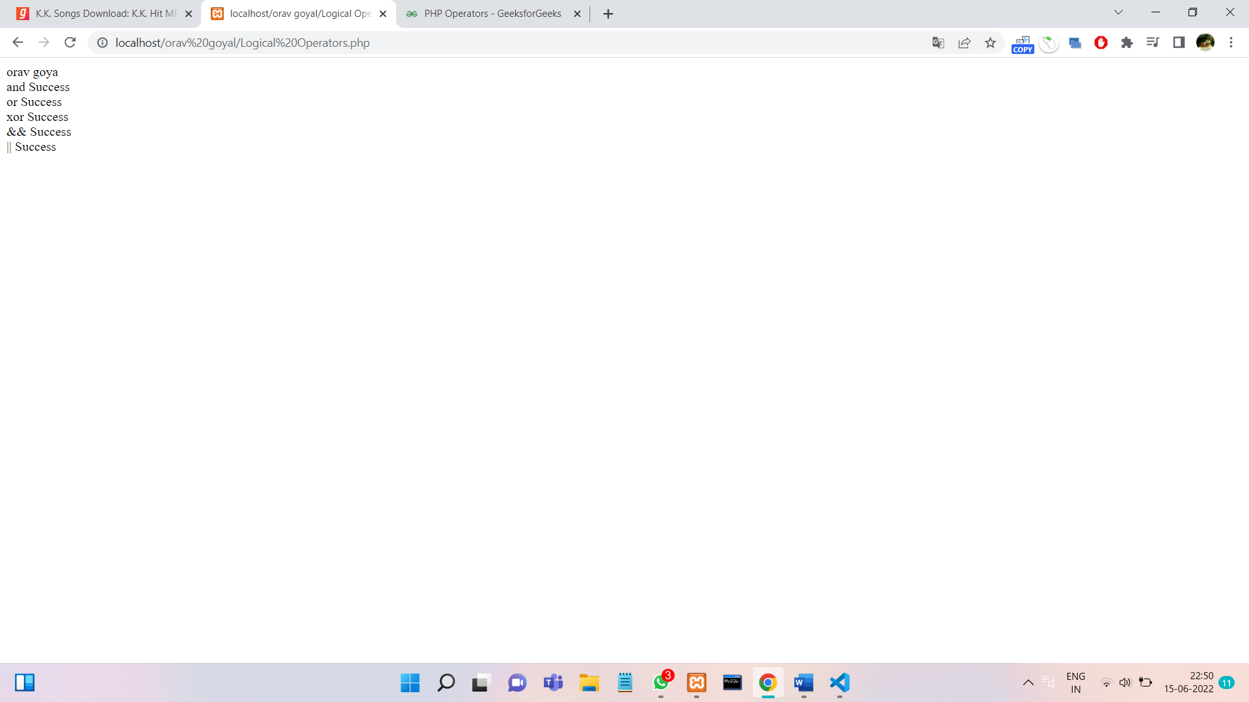

**TERNARY OPERATORS:**

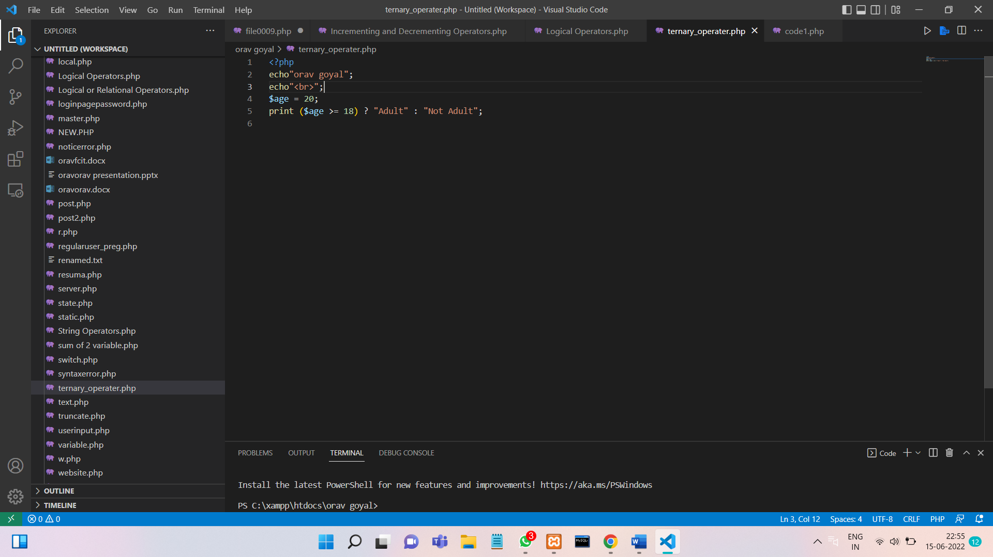

**OUTPUT :**

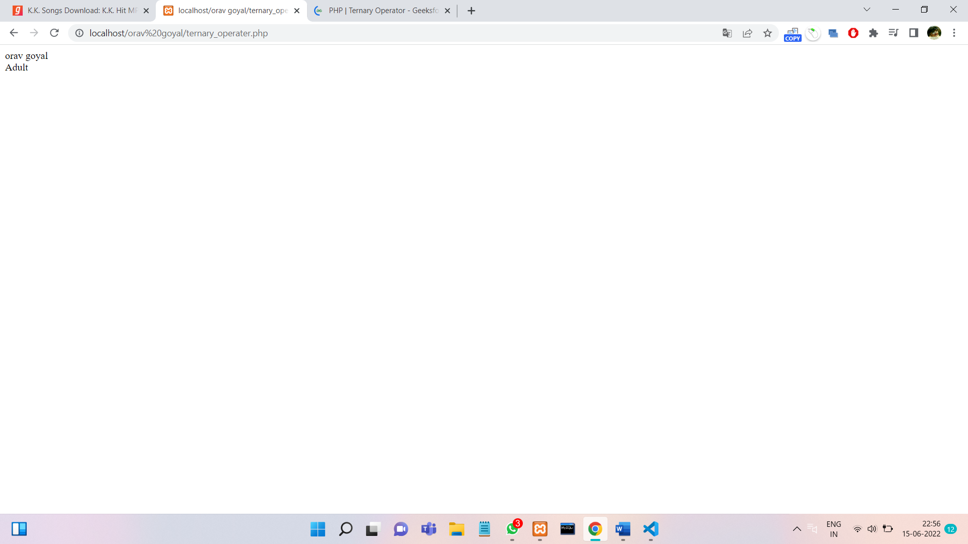

**PROGRAM 2.**

**Write a program to show the usage of the nested if statement.**

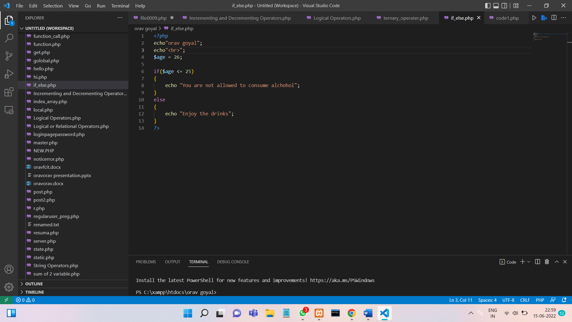

**OUTPUT :**

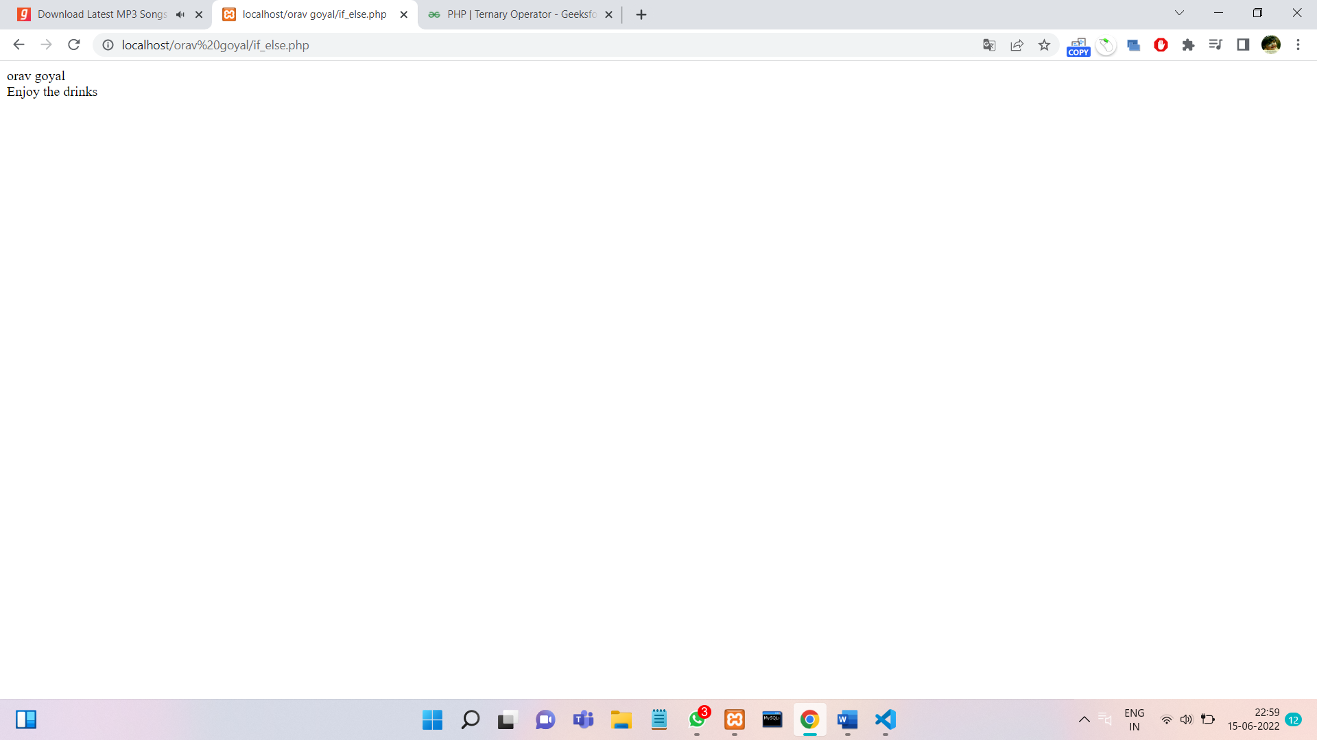

**PROGRAM 3.**

**Write a Program in PHP for type Casting of a Variables.**

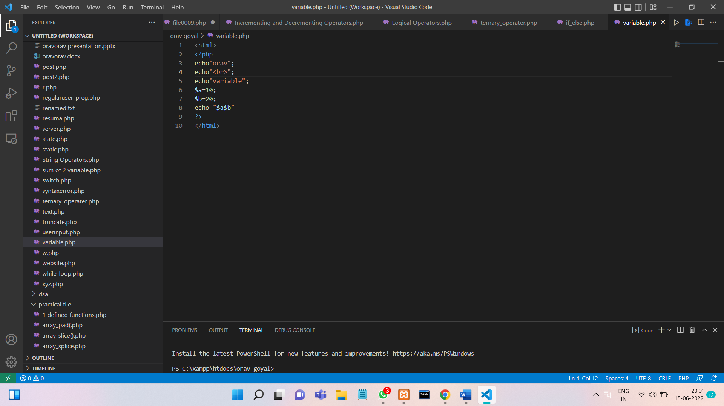

**OUTPUT :**

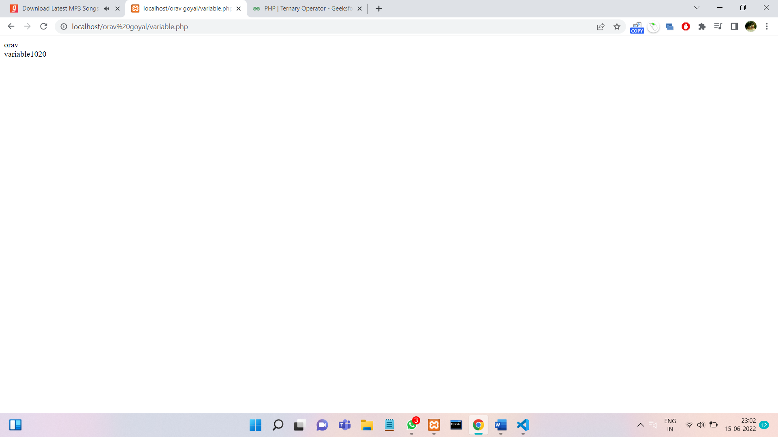

**PROGRAM 4.**

**Write a program to create a menu-driven program and show the usage of switch-case.**

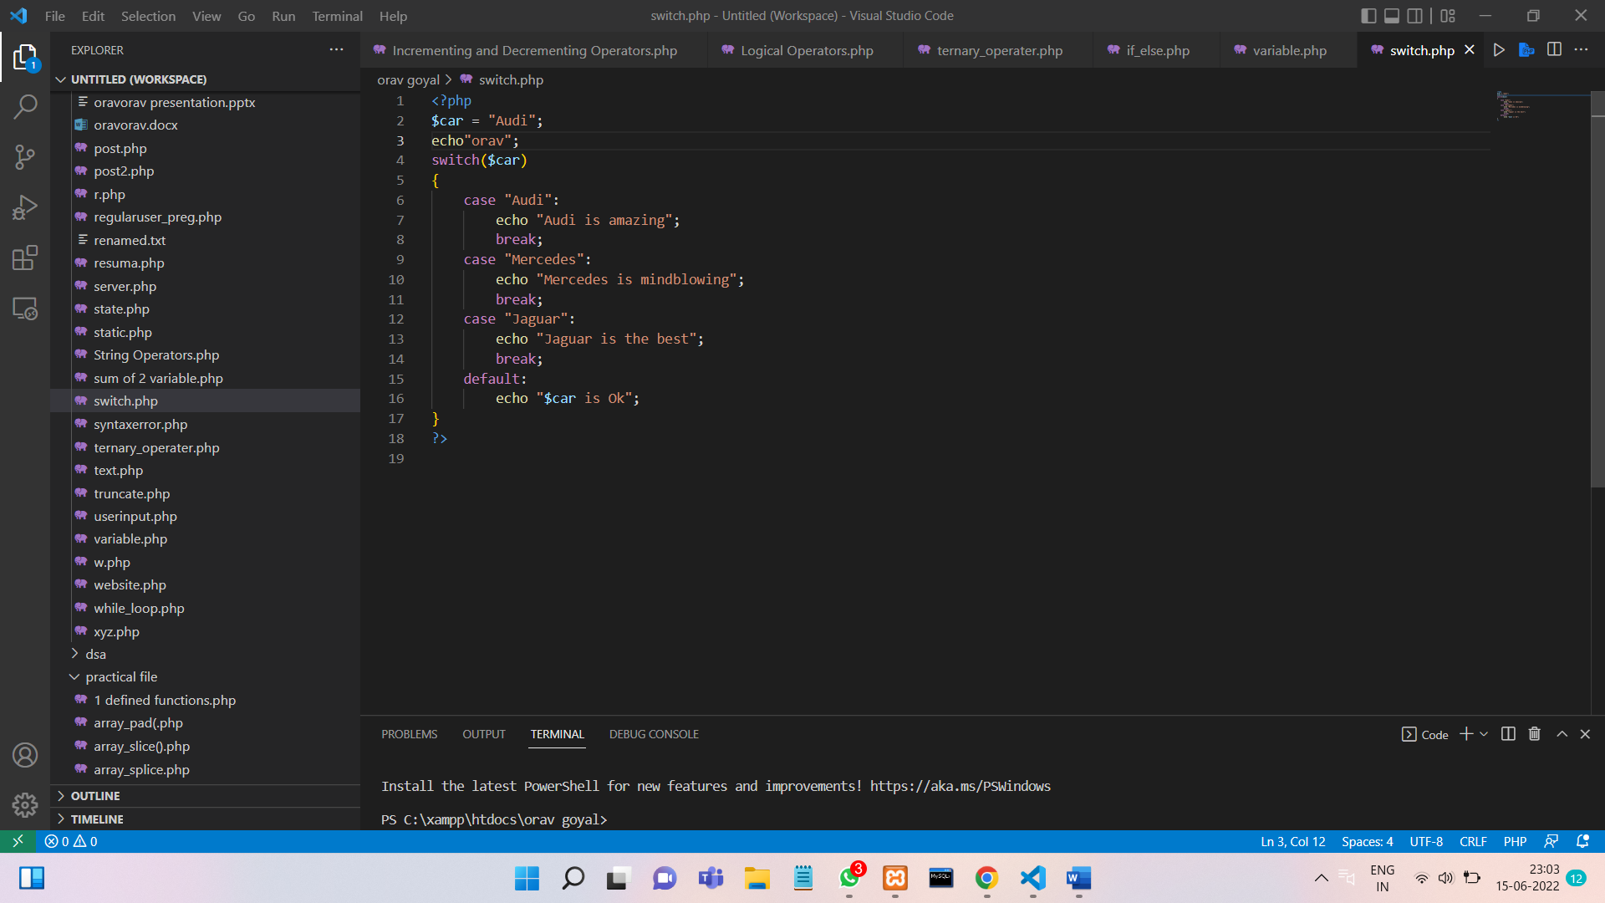

**OUTPUT :**

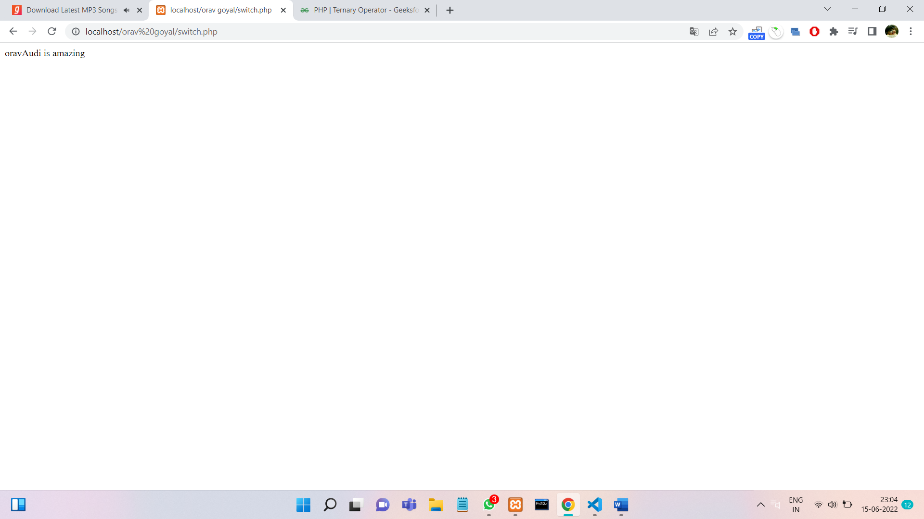

**PROGRAM 5.**

**Write a program to show the usage of for/while/do-while loop.**

**->FOR LOOP**

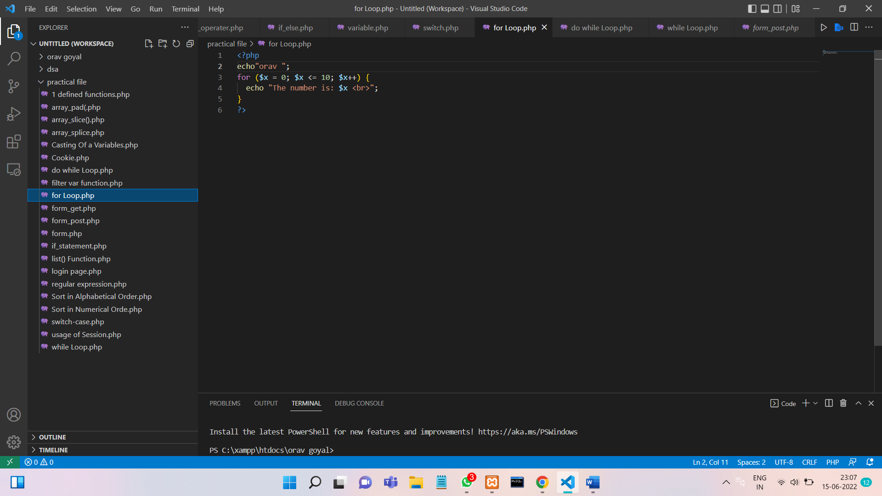

**OUTPUT :**

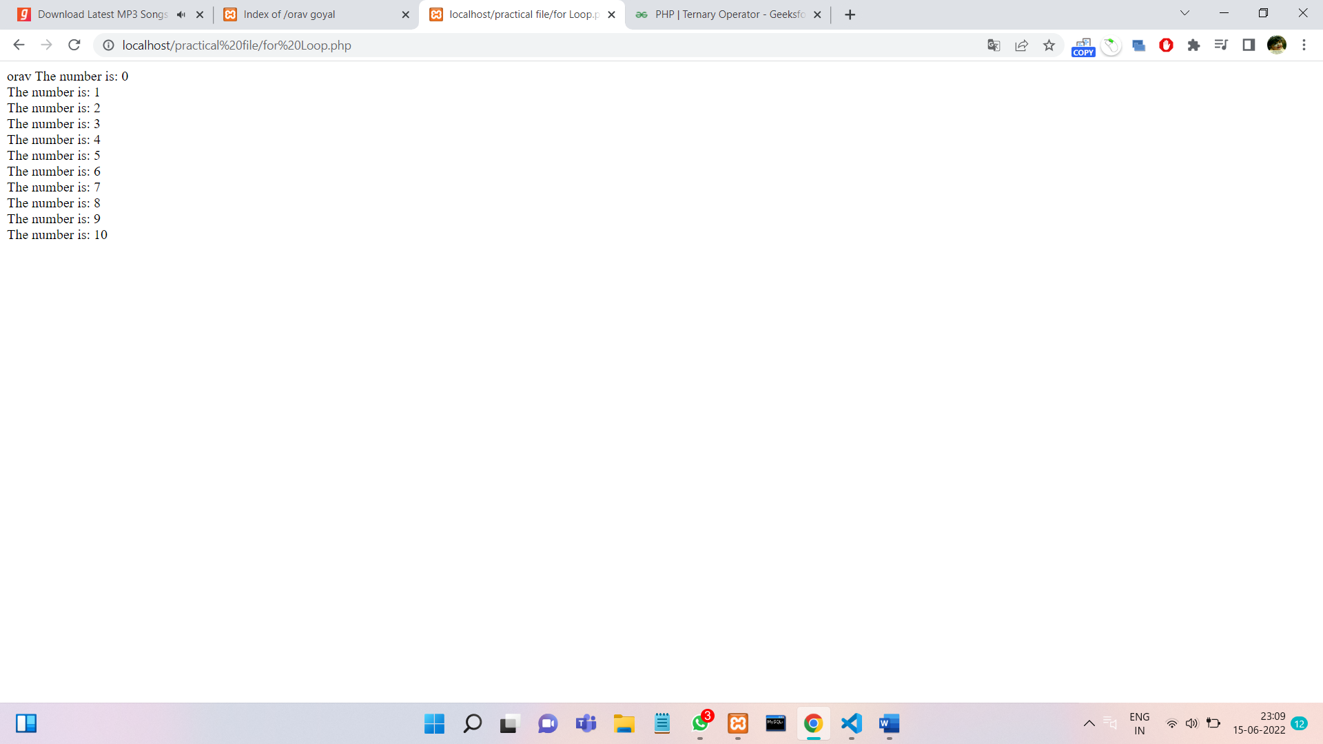

**->WHILE LOOP**

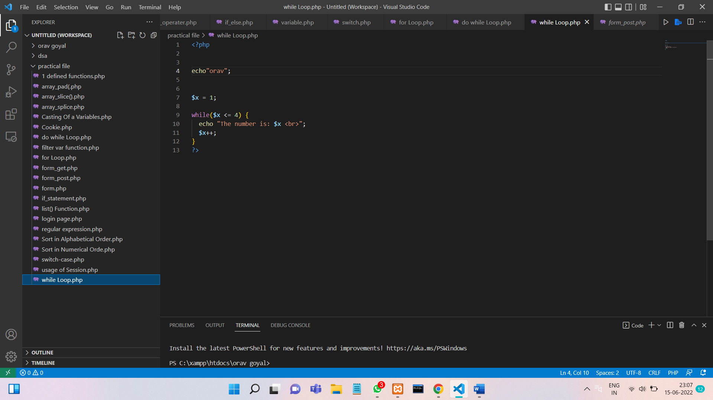

**OUTPUT :**

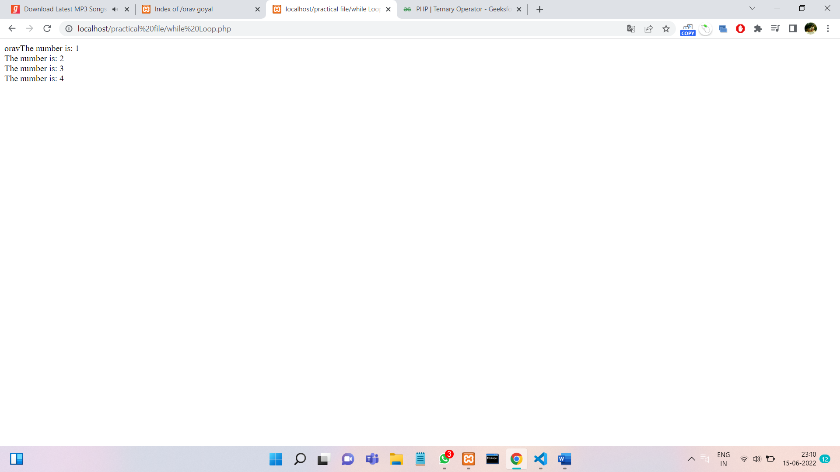

**->DO-WHILE LOOP**

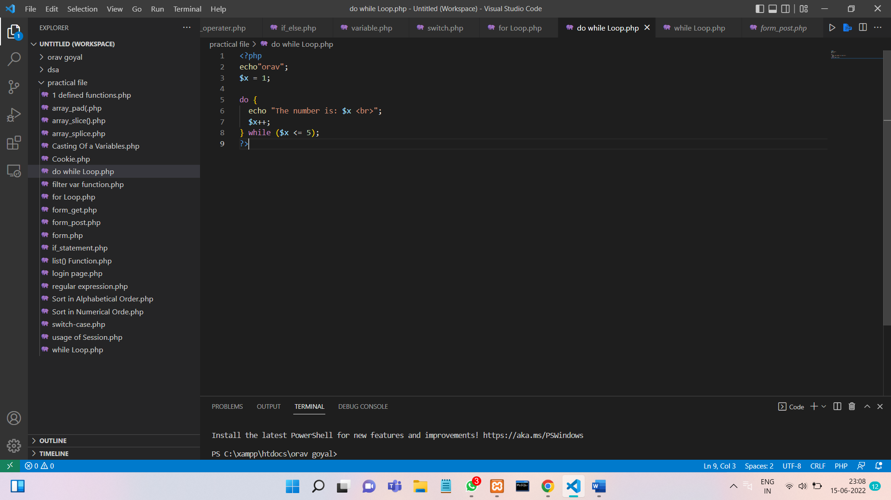

**OUTPUT :**

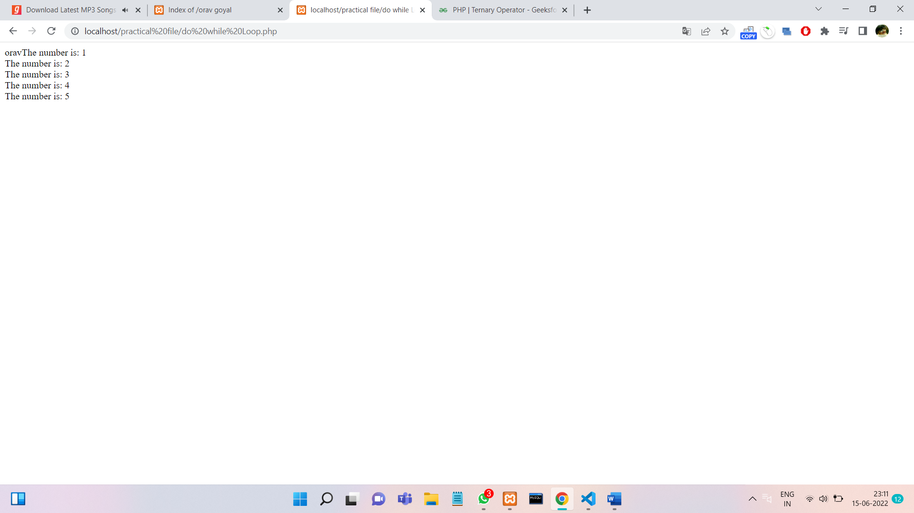

**PROGRAM 6.**

**Write a program to perform all four types of sorting.**

**Shorting by number**

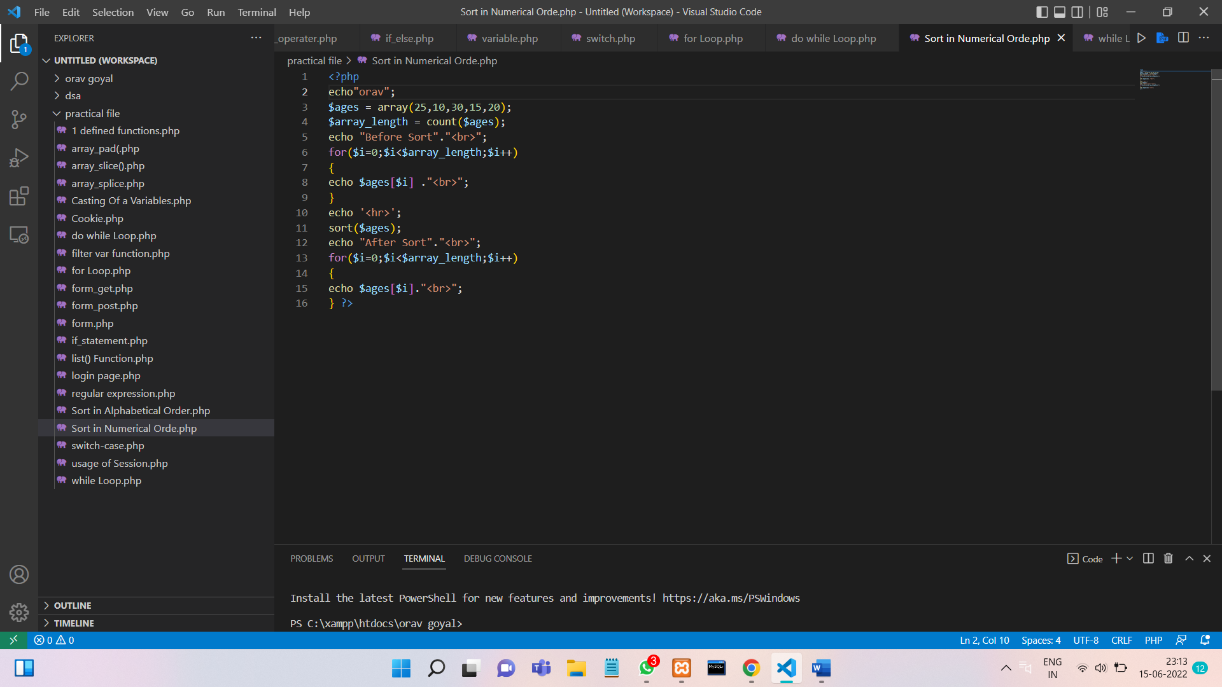

**Output**

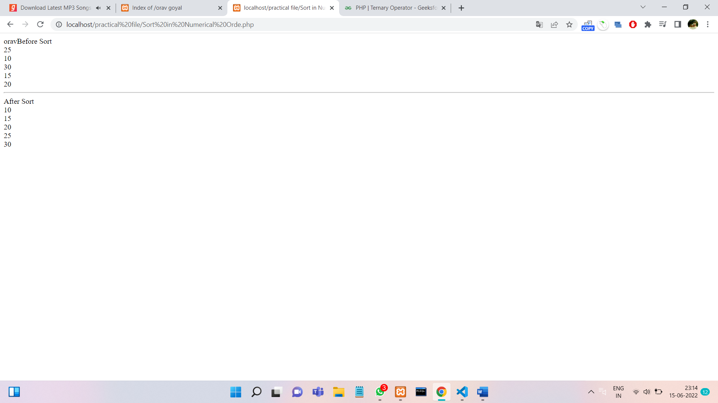

**Shorting by Alphabetical**

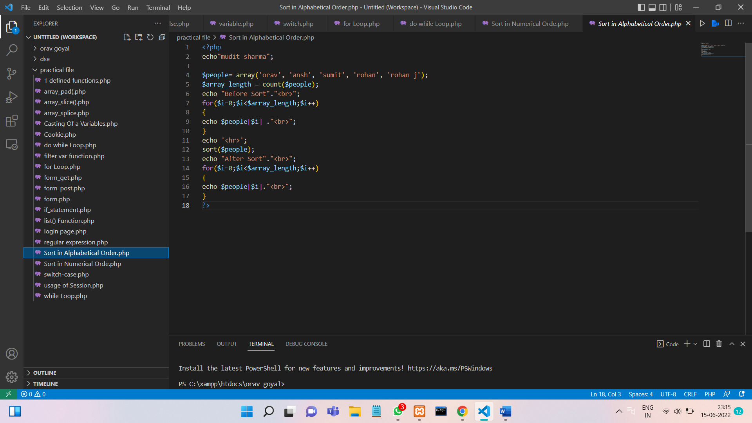

**Output**

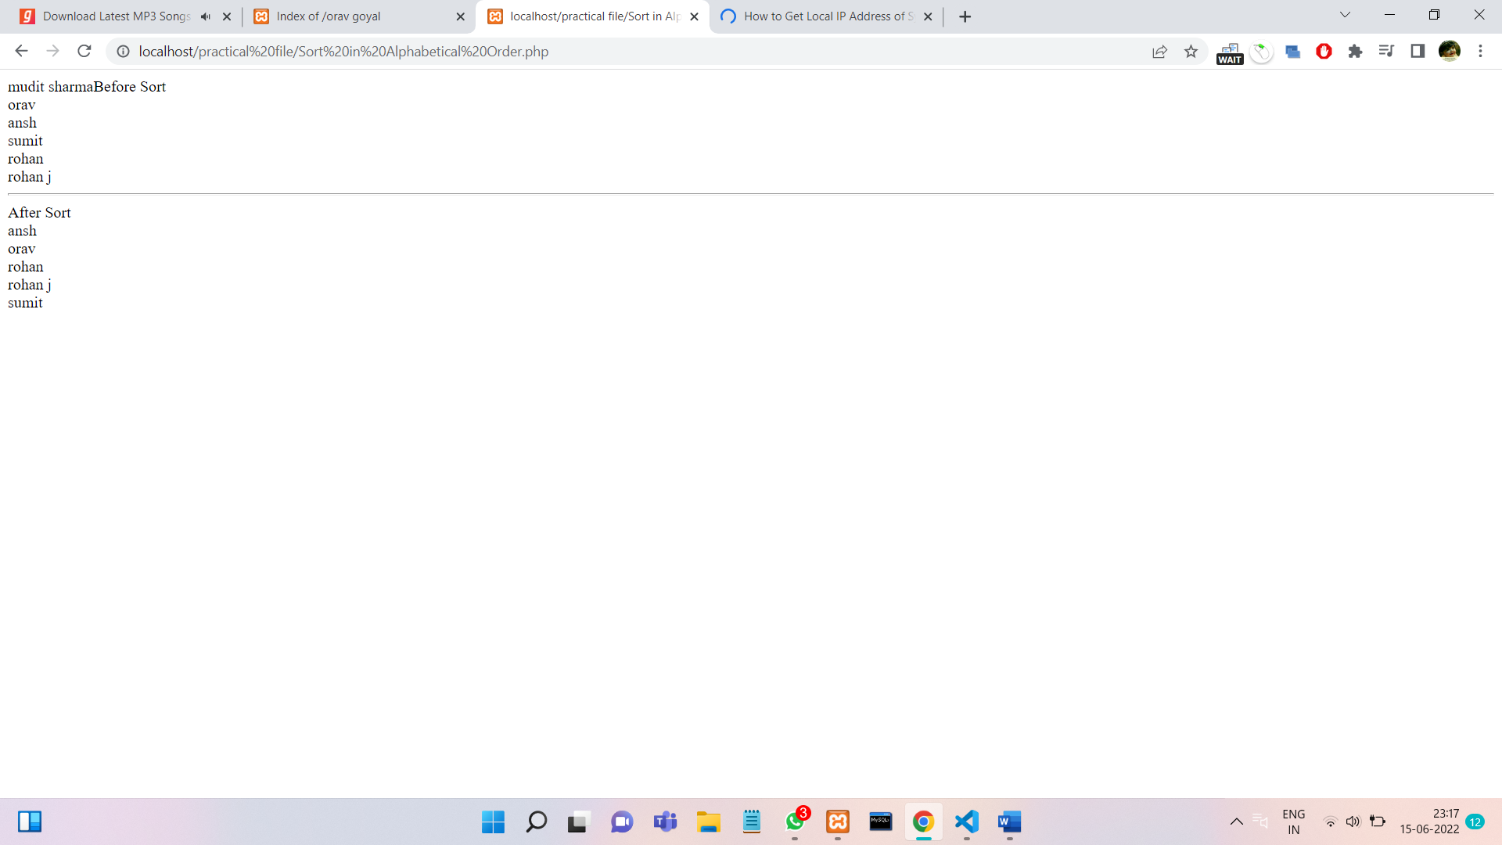

**PROGRAM 7.**

**Write a program to implement Arraypad(),aaray_slice(),array_splice(),list() functions.(use foreach wherever applicable)**

**List function**

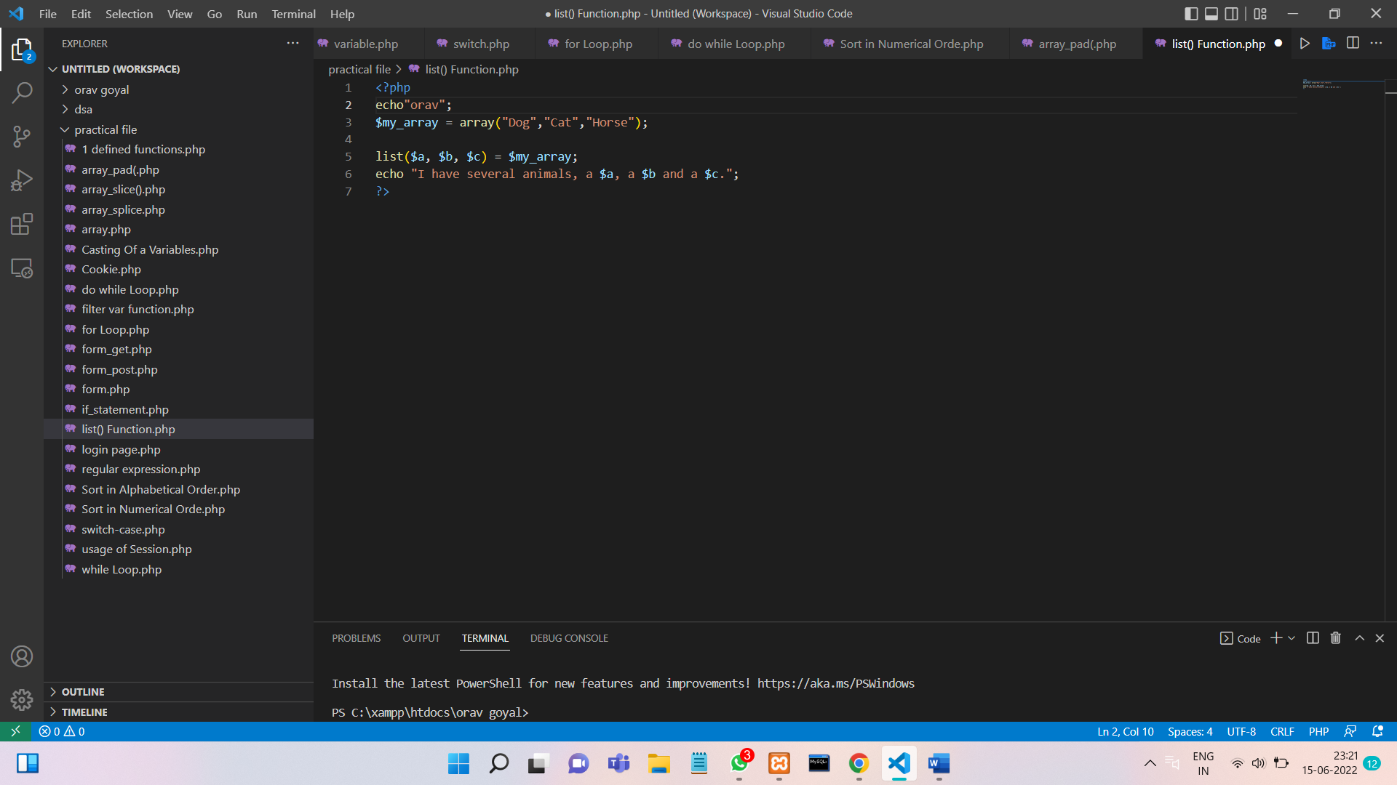

**OUTPUT :**

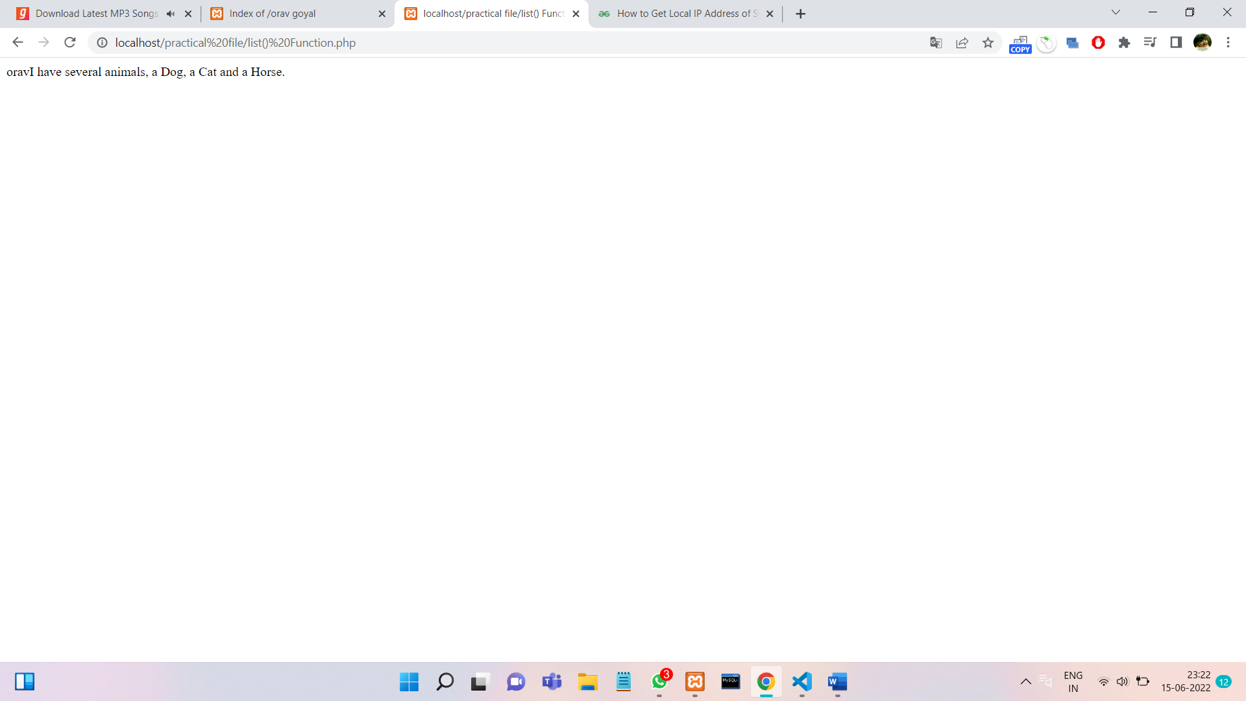

**Array pad**

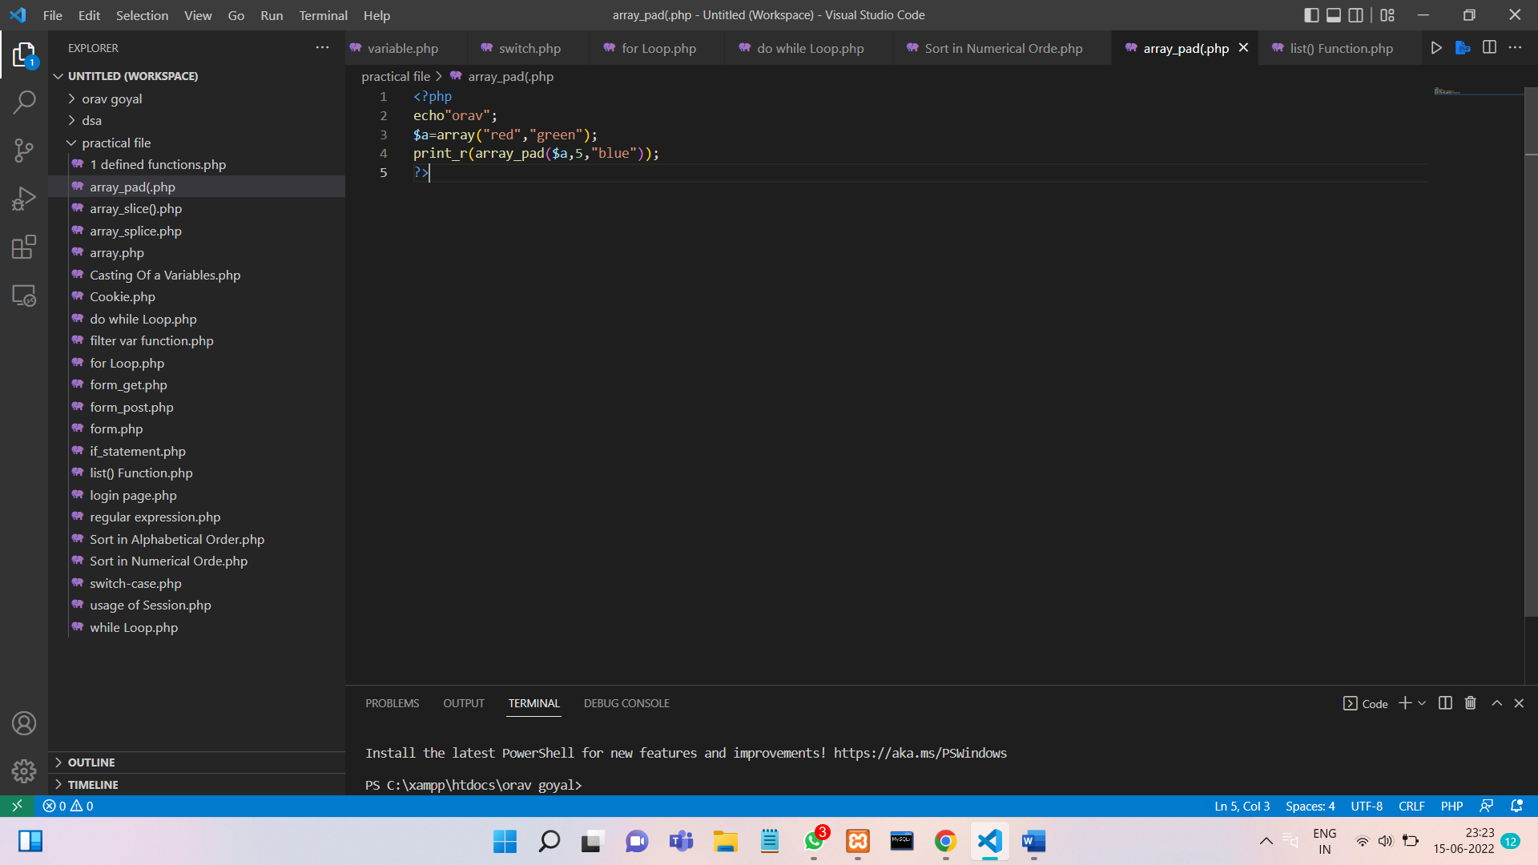

**Output**

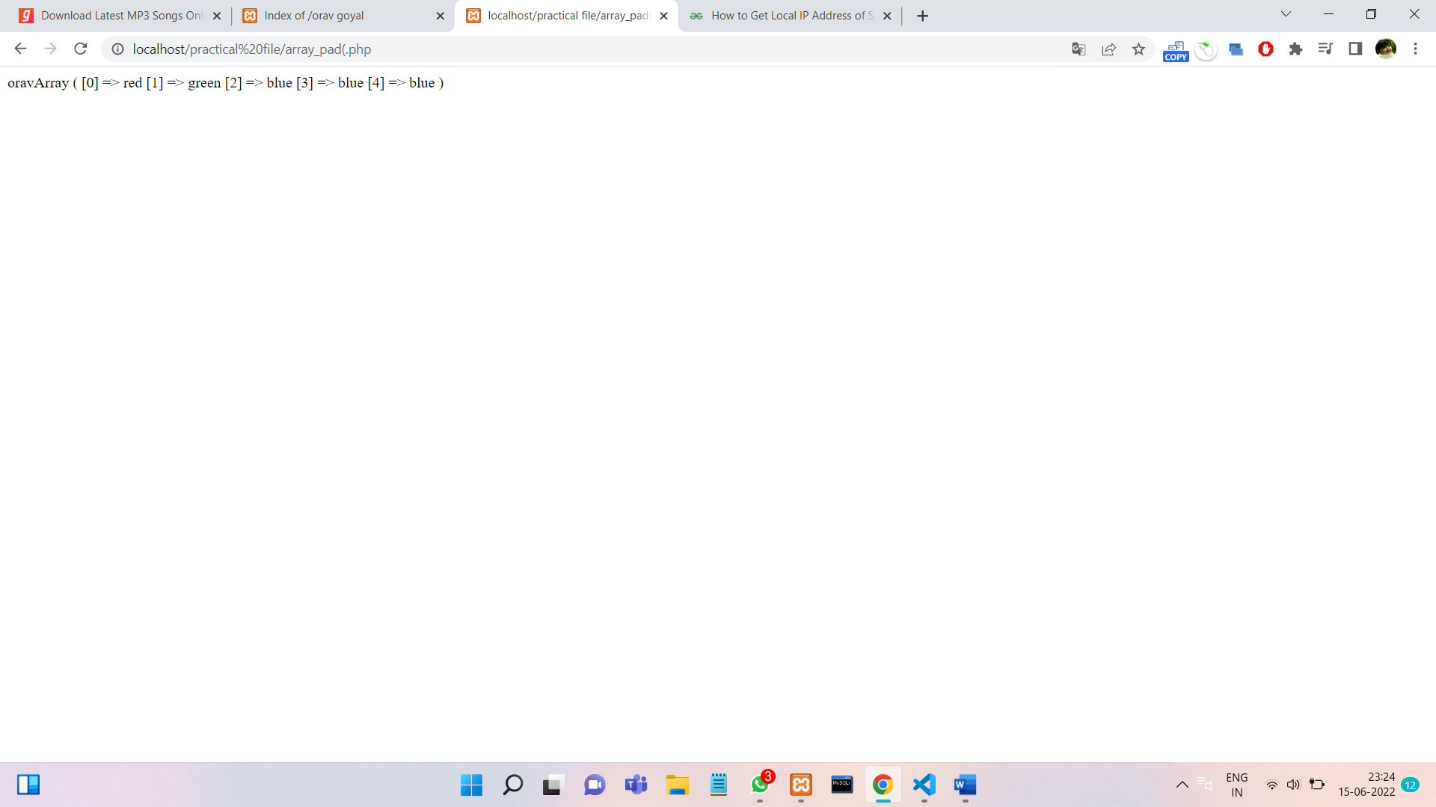

**PROGRAM 8.**

**Write a program to show the application of user-defined functions.**

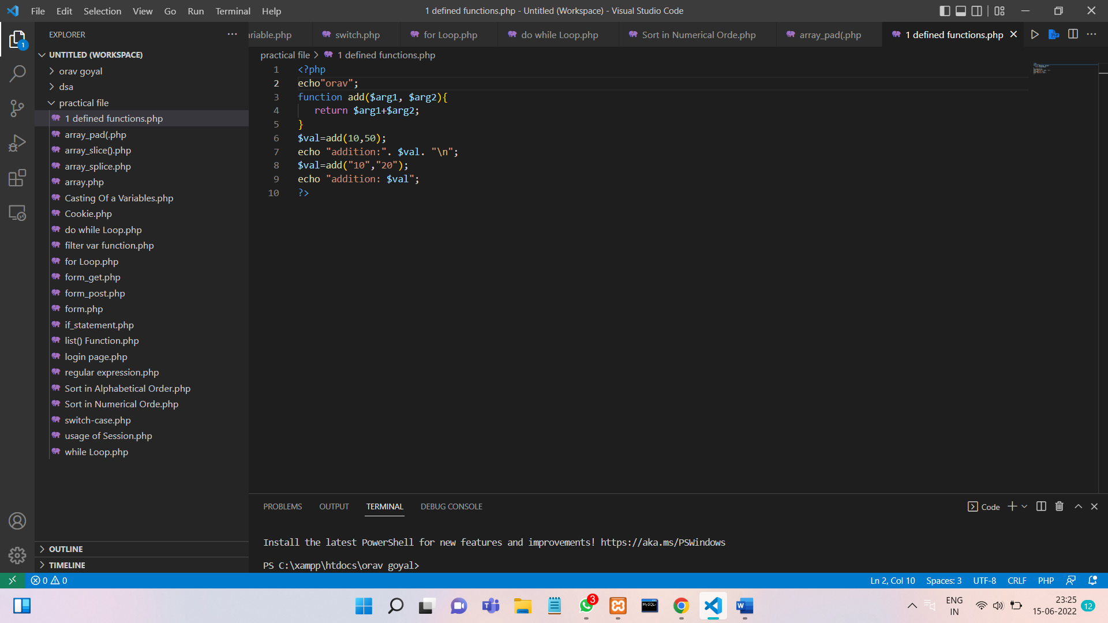

**OUTPUT :**

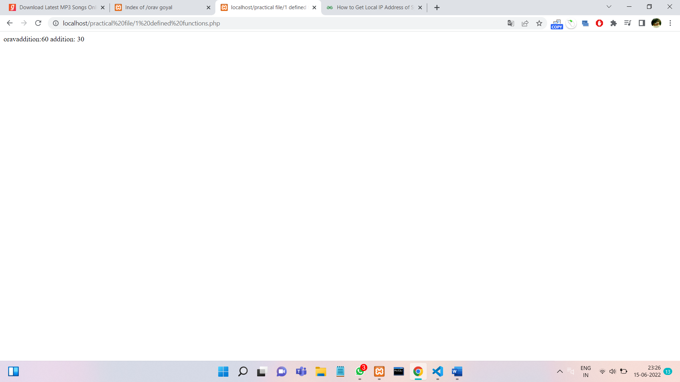

**PROGRAM 10.**

**Write a program to validate the form data using the Filter var() function.**

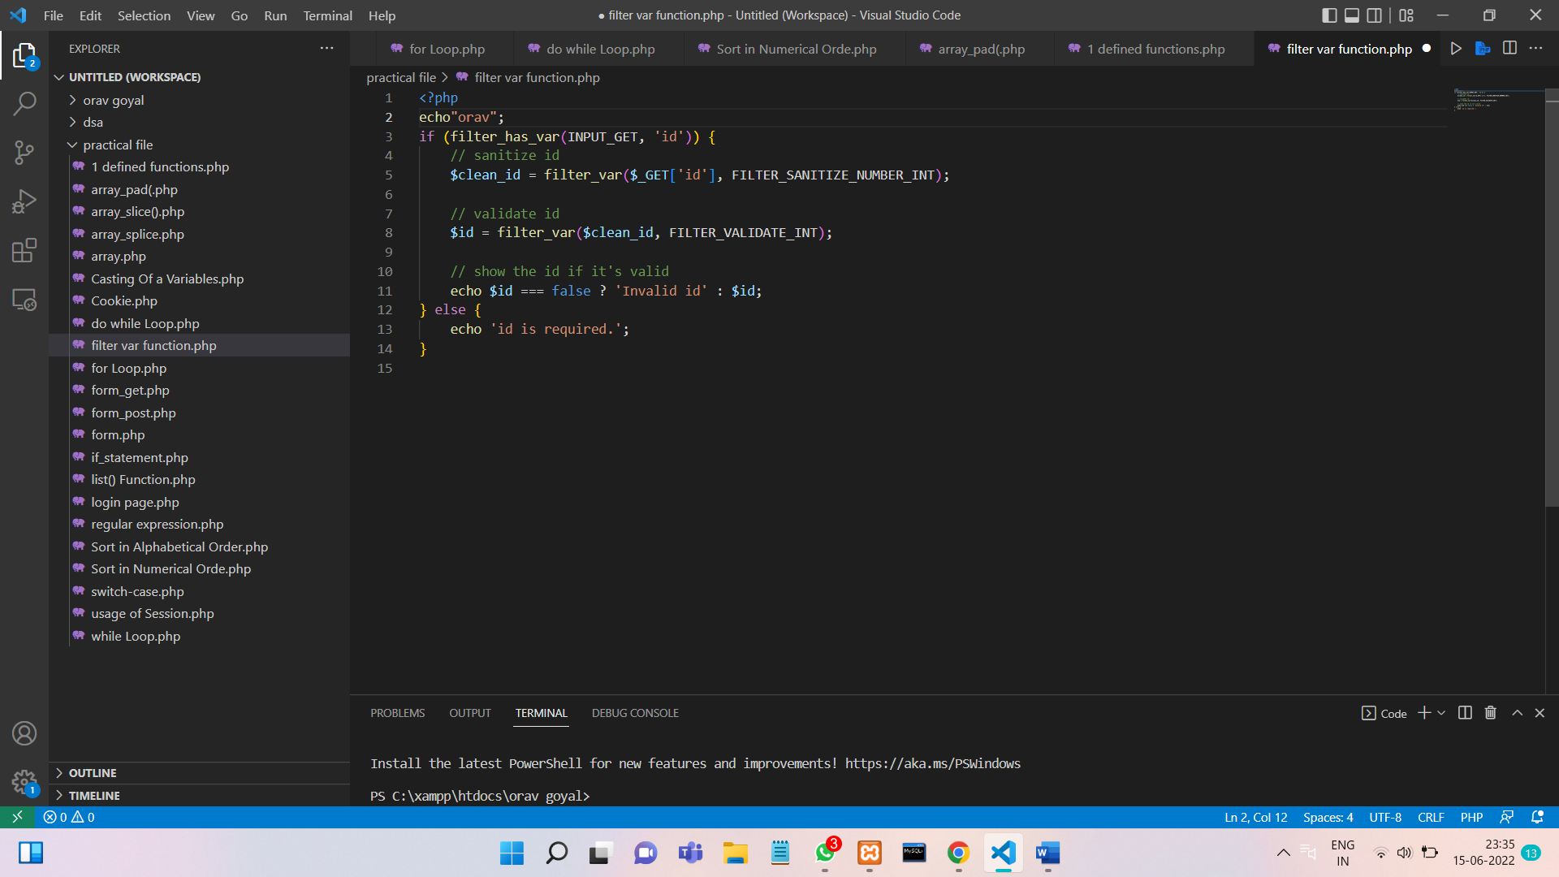

**OUTPUT :**

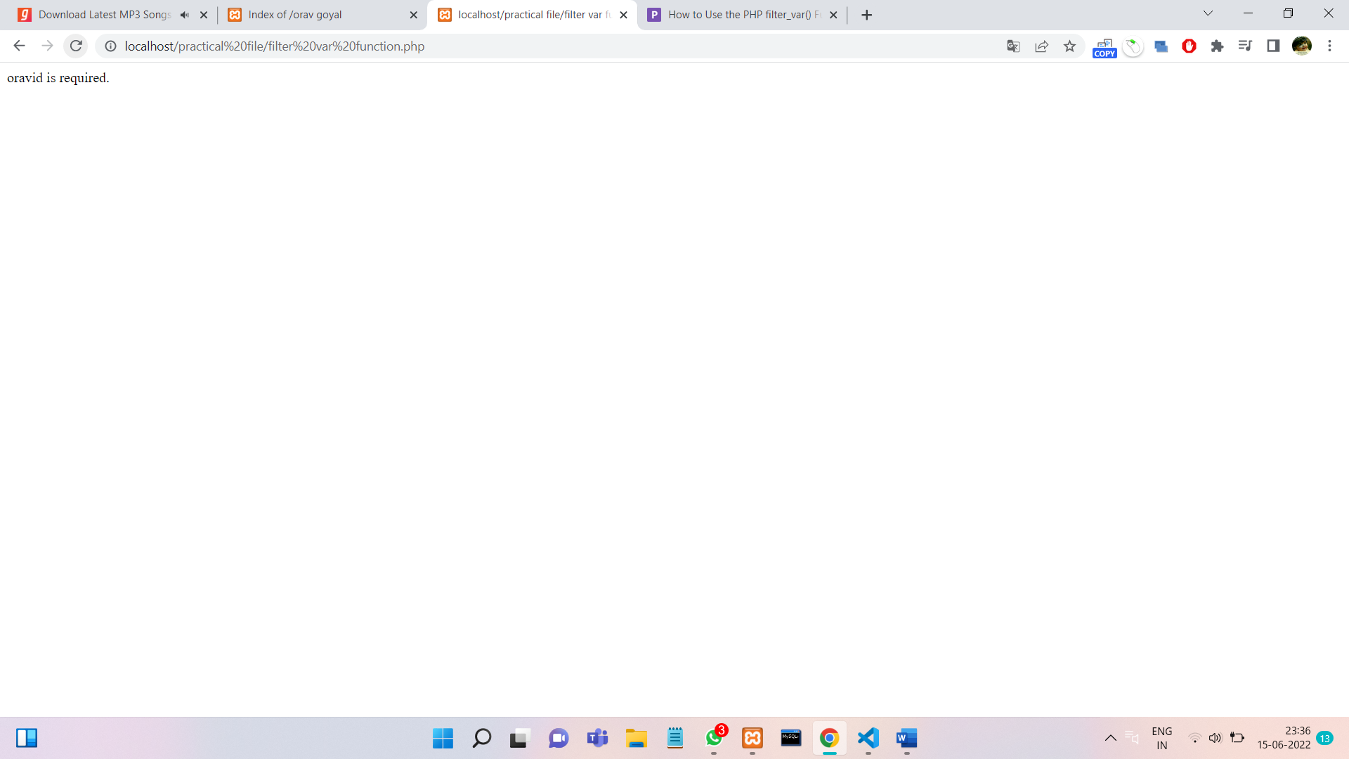

**PROGRAM 11.**

**Write a program to show the usage of Cookies.**

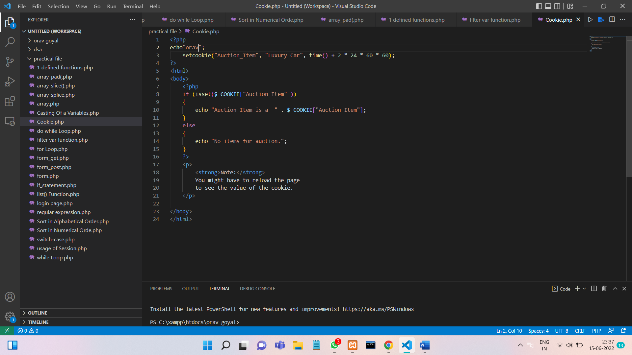

**OUTPUT :**

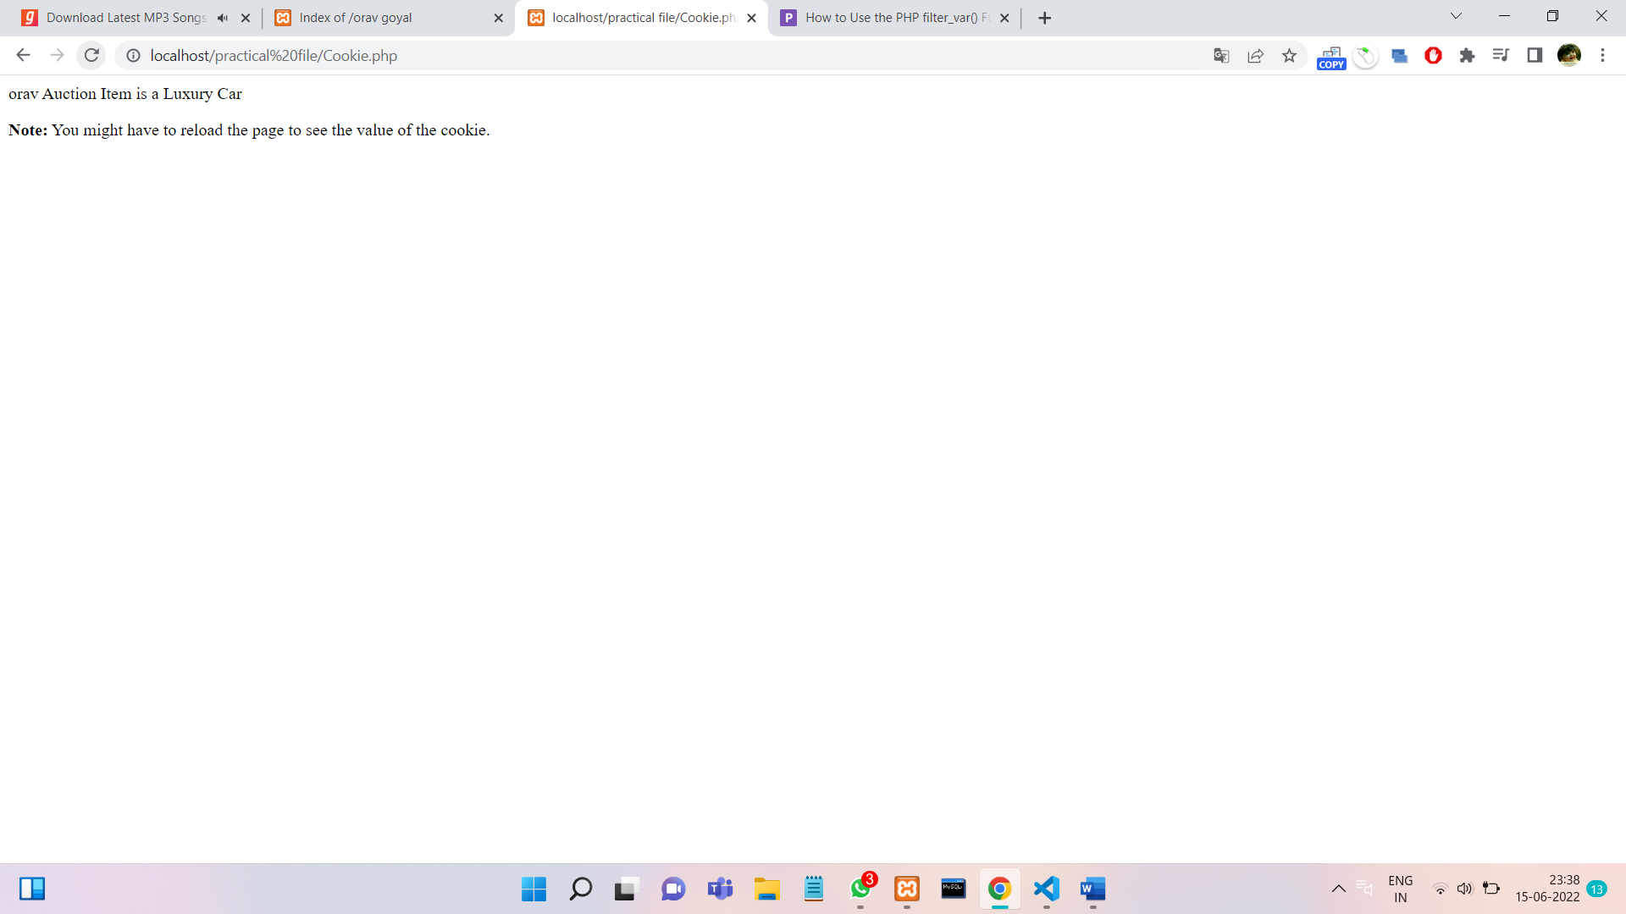

**PROGRAM 12.**

**Write a program to show the usage of Session.**

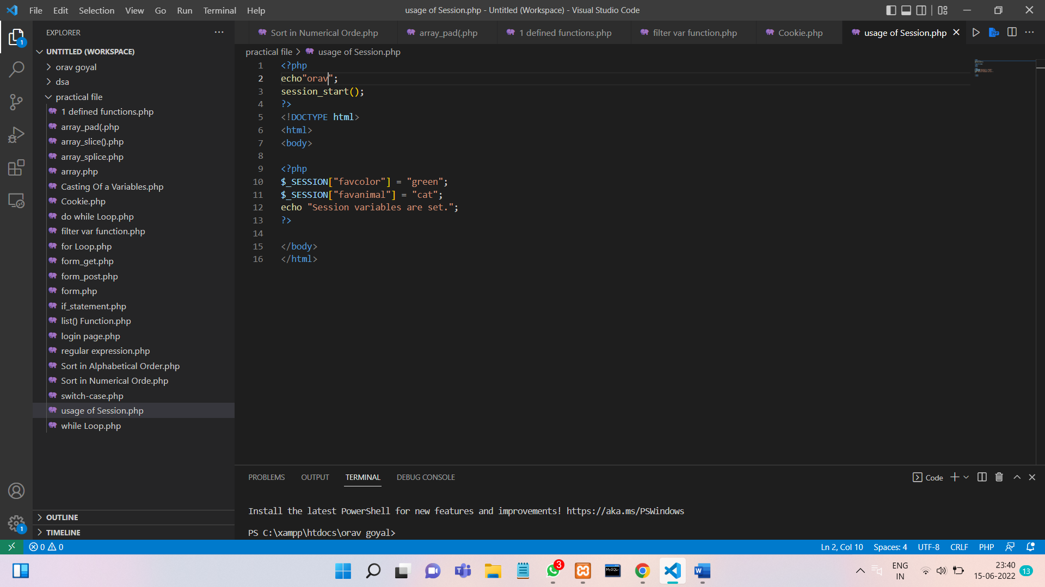

**OUTPUT :**

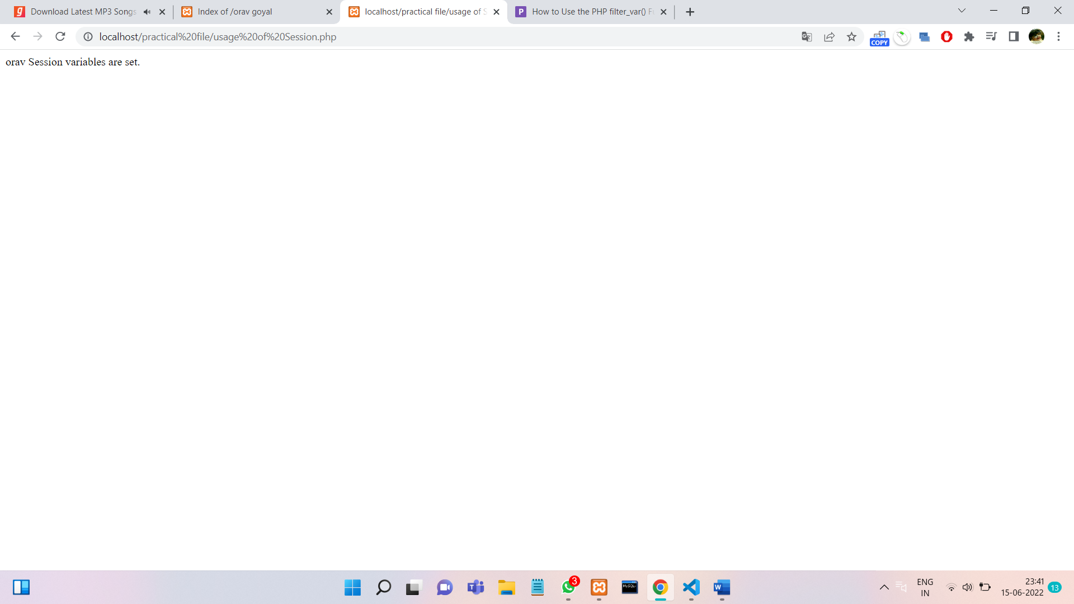

**PROGRAM 13.**

**Write a program to implement the oops concept.**

**OUTPUT :**

**PROGRAM 14.**

**Do Form handling In PHP Design a personal Information form, then Submit & Retrieve the Form Data Using $_GET(), $_POST() and $_REQUEST() Variables.**

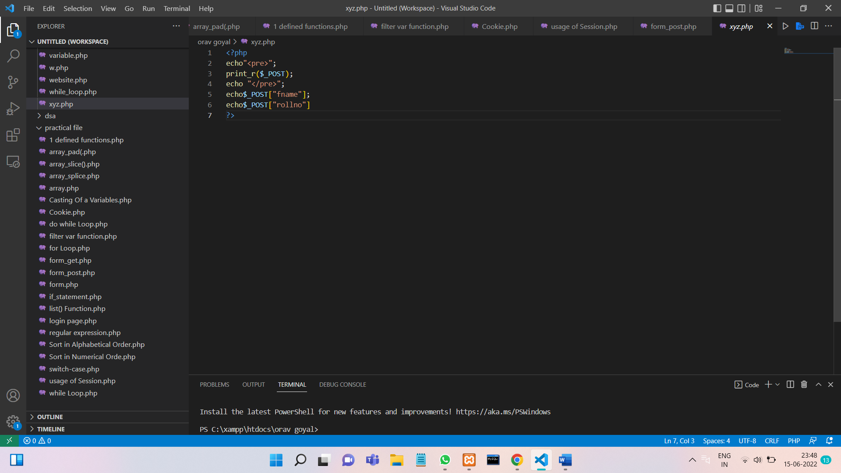

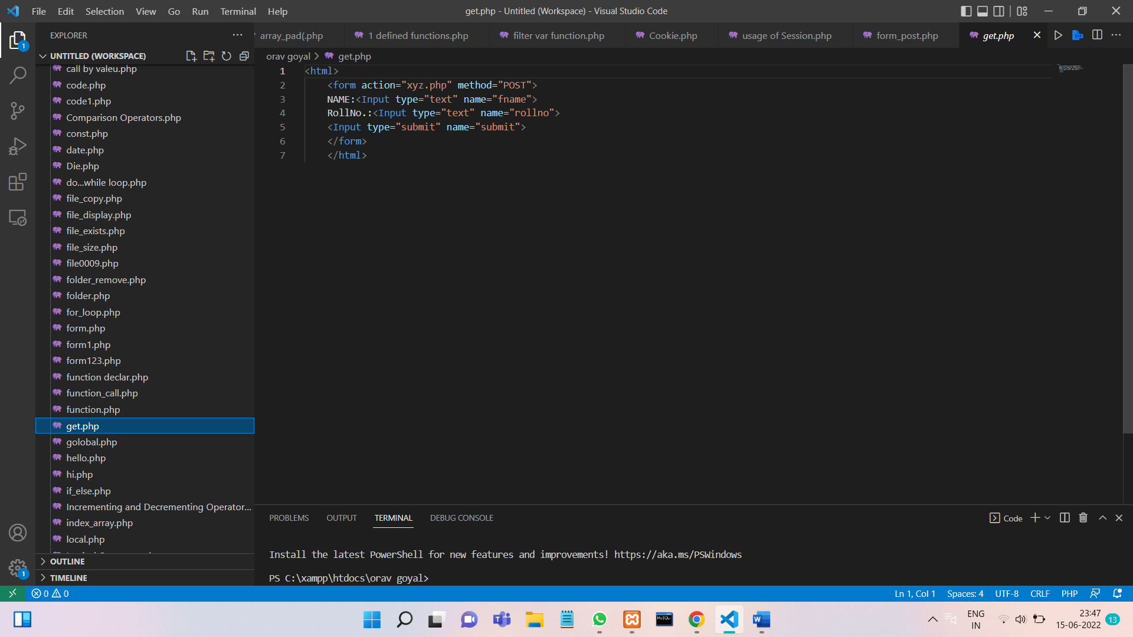

**OUTPUT :**

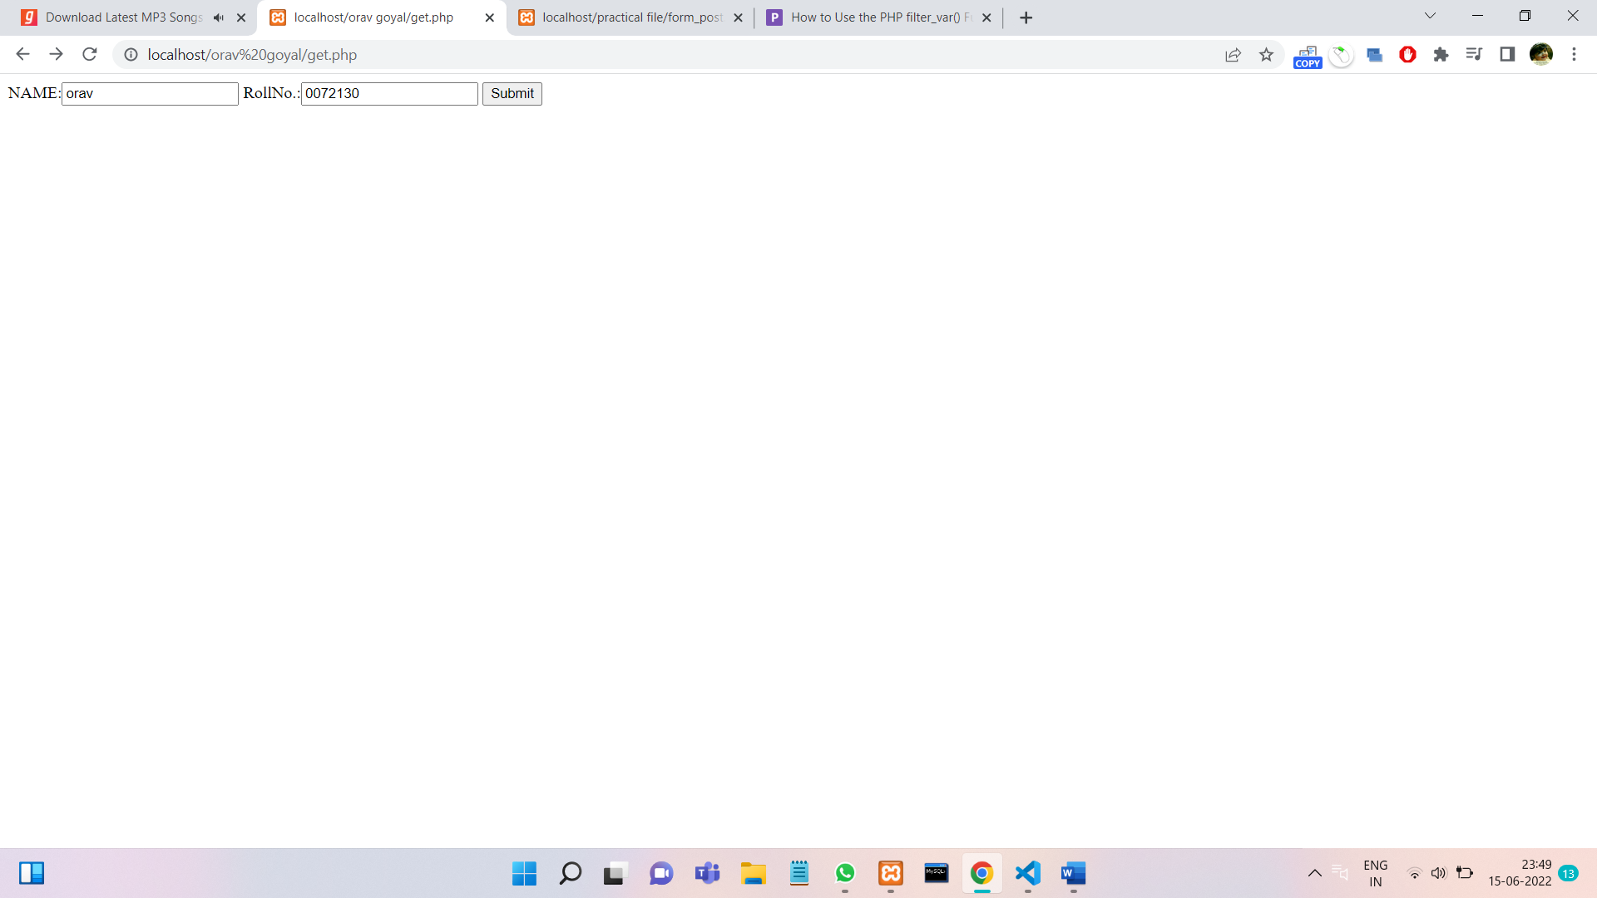

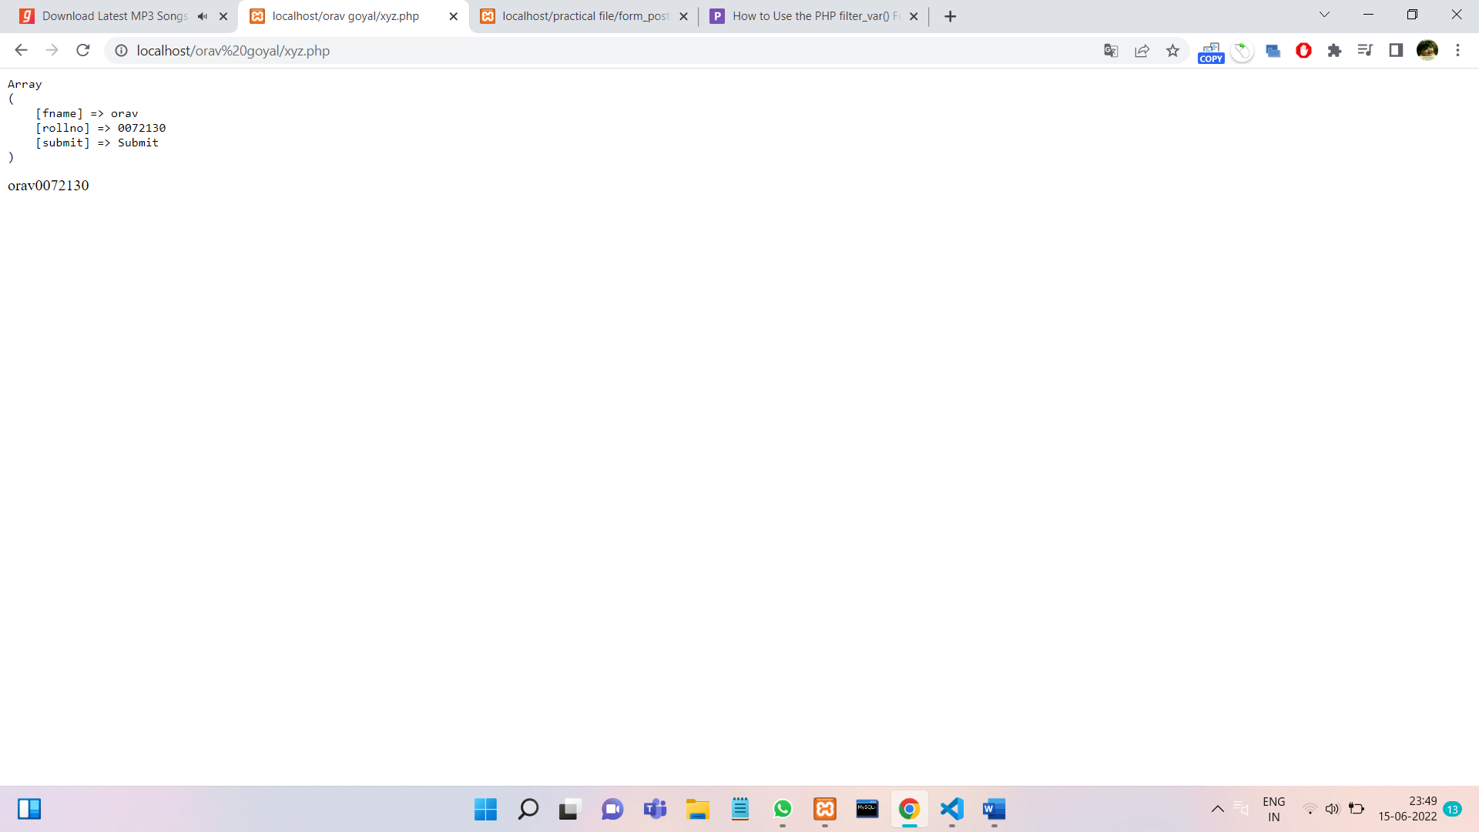

**PROGRAM 15.**

**Design A Login Form and Validate that Form using PHP Programming.**

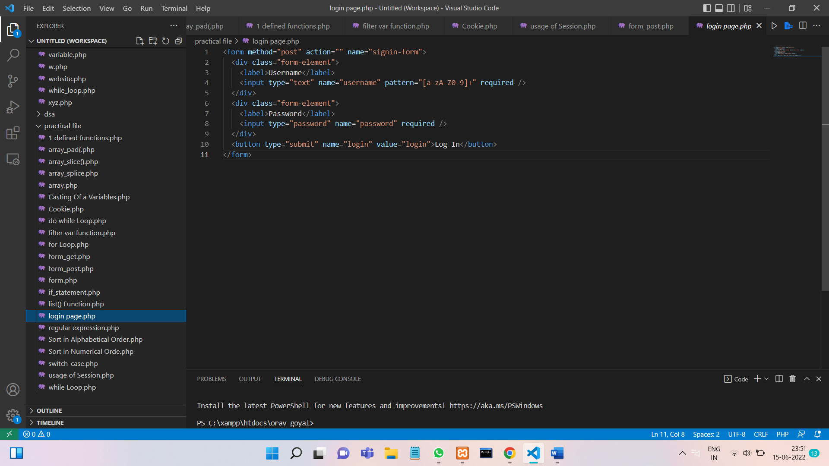

**OUTPUT :**

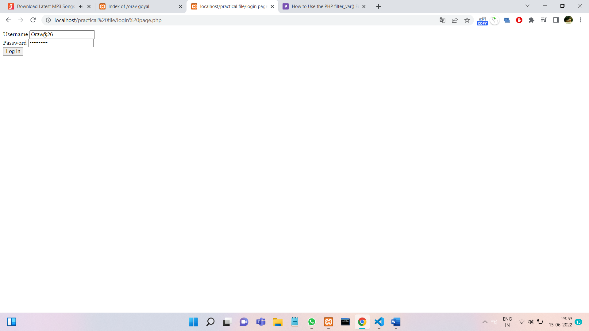

**PROGRAM 16.**

**Create Admin Login, Logout form using session variables**

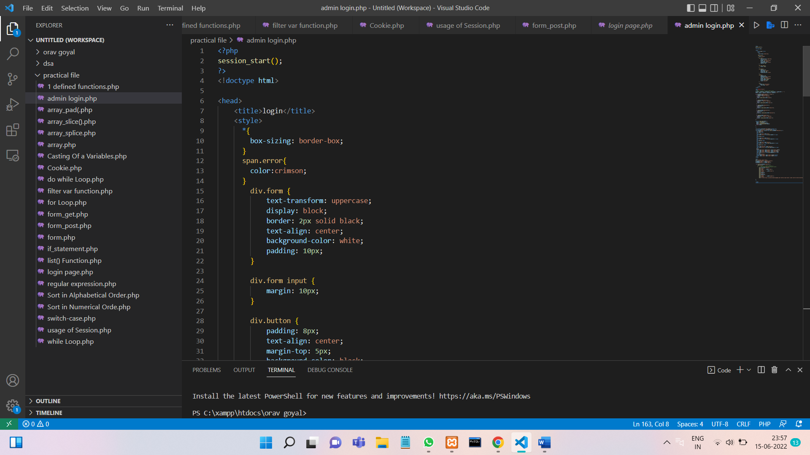

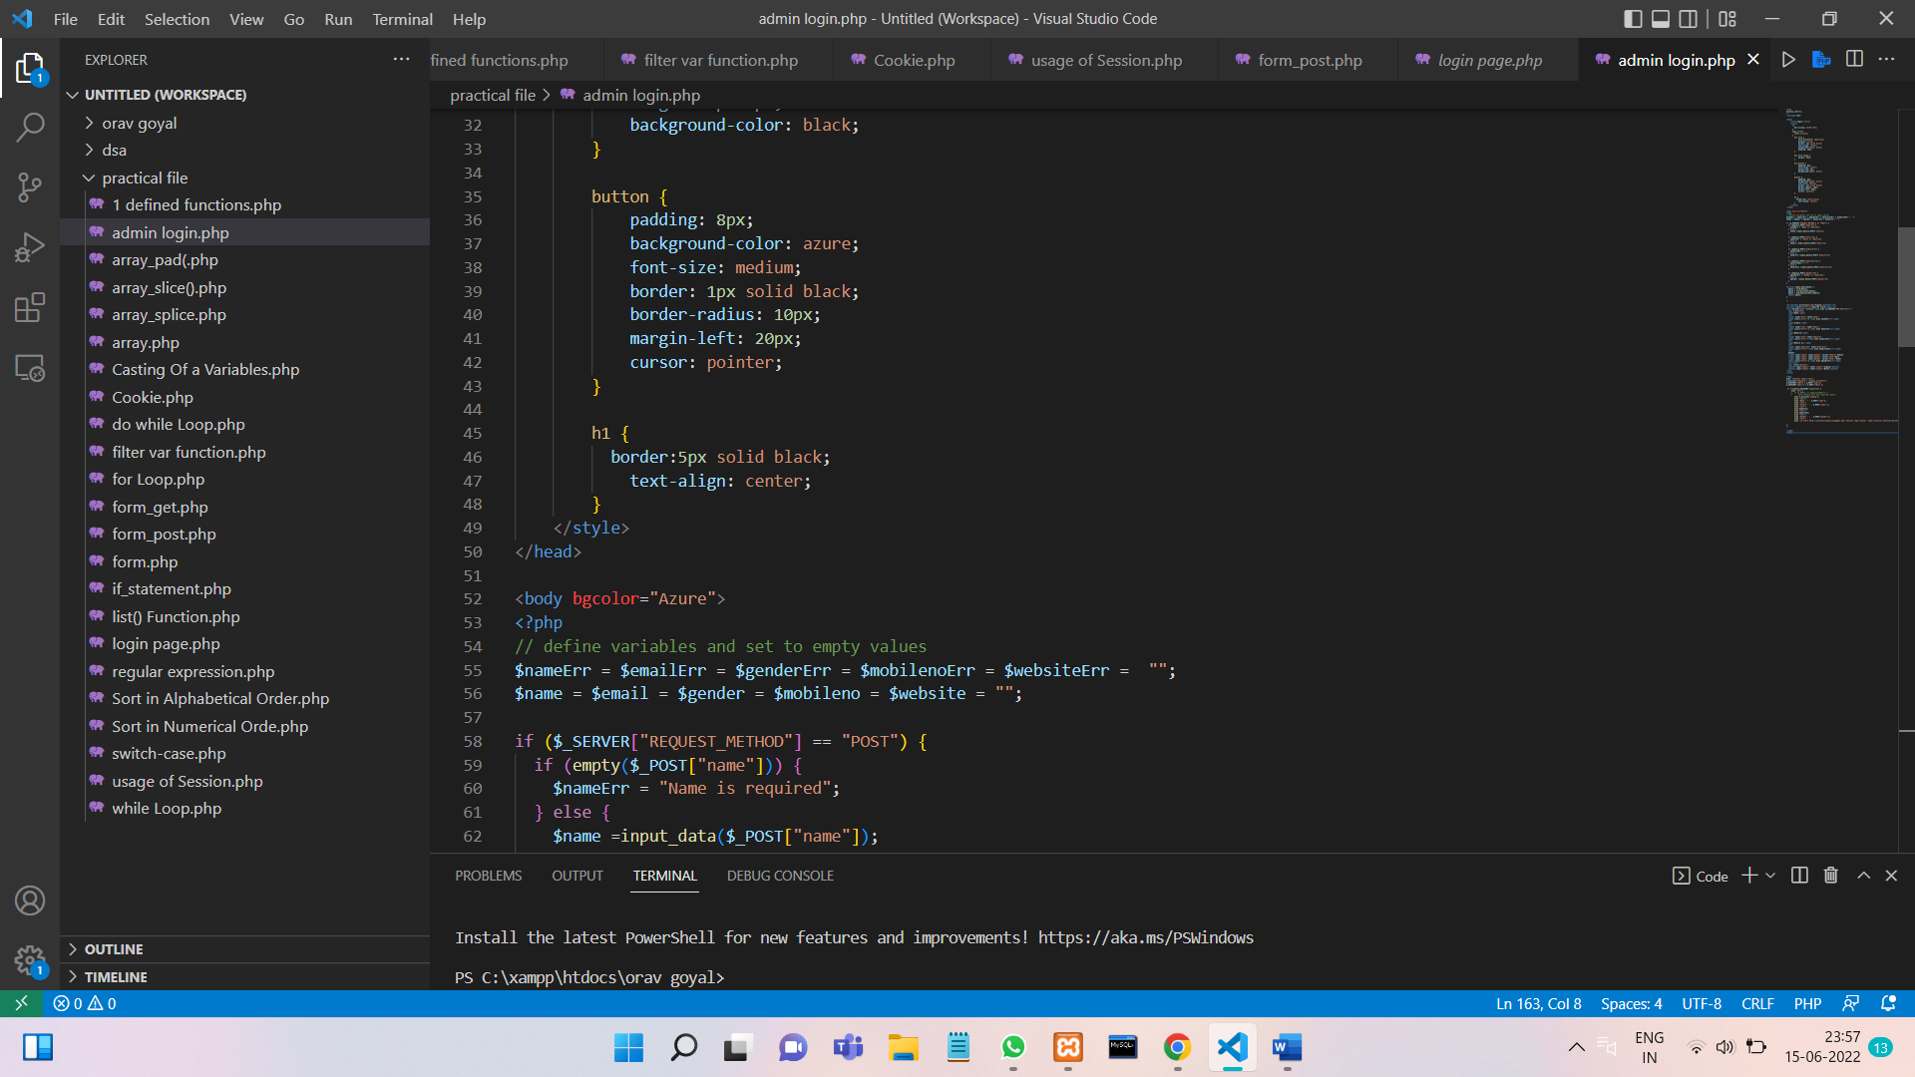

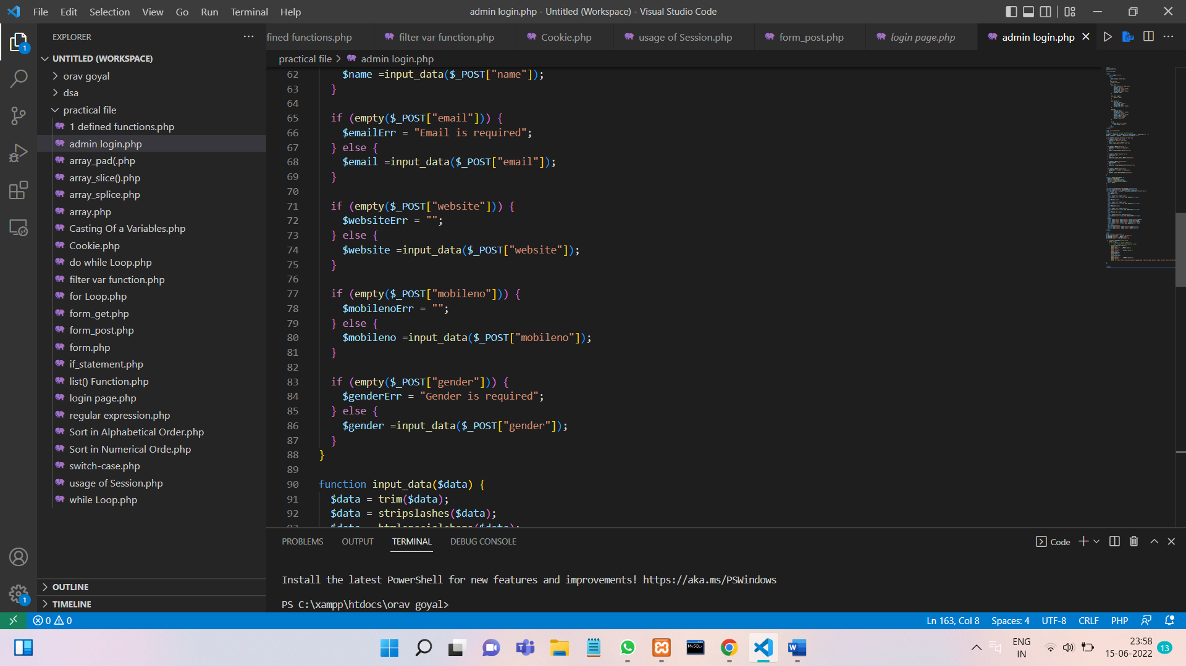

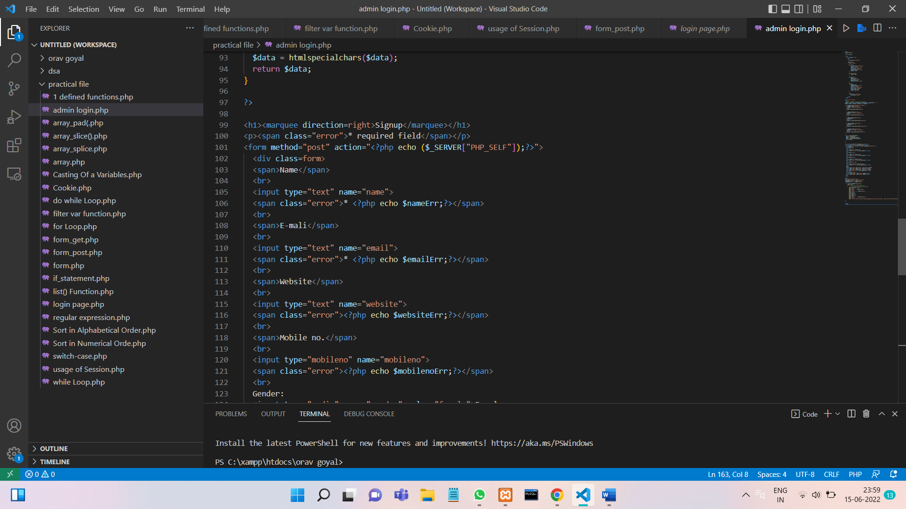

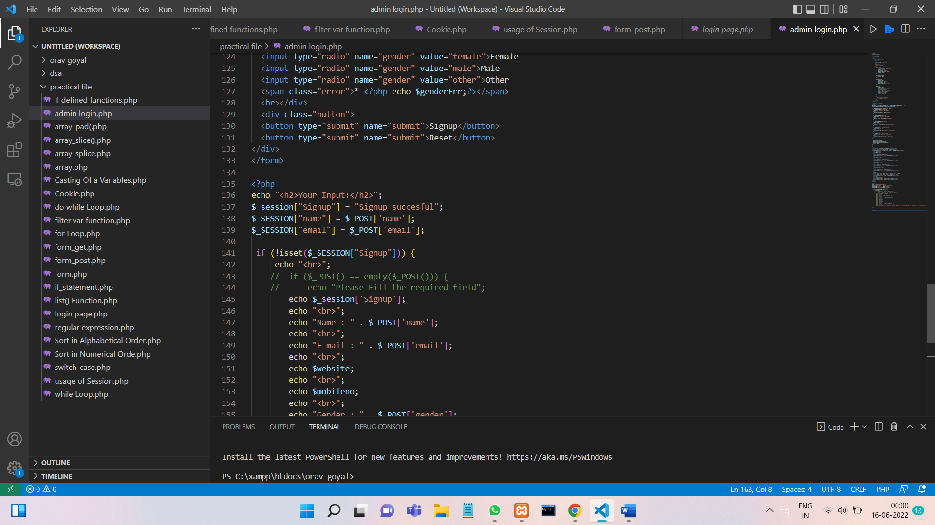

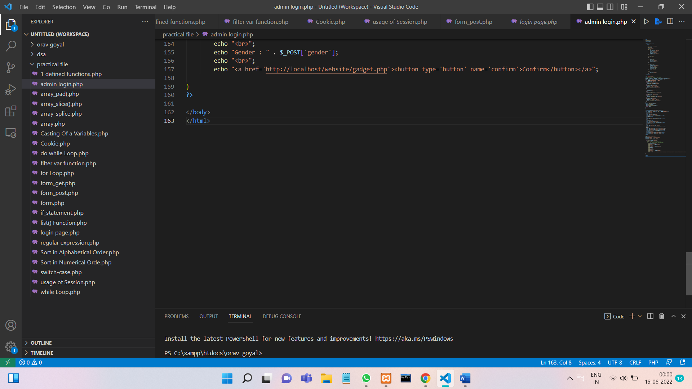

**Output;**

